INDEX

Introduction 3

MS SQL Server (Versions Overview) 12

Structured Query Language (SQL) 20

Databases 22

Tables 32

Data Types 42

Constraints 47

Rules and Defaults 57

Joins 61

Sub Queries 68

Built-in Functions 74

Operators 80

Views 85

Synonyms 90

Normalization 92

Back-up and recovery of Databases 100

Frequently Asked Questions 104

INTRODUCTION

SQL Server is a Client/Server Relational Database Management System (RDBMS) that uses Transact-SQL to send request between a client and SQL Server.

Client/Server Architecture:
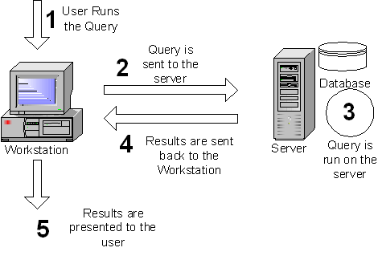

SQL Server is designed to be a client/server system. Client/server systems are constructed so that the database can reside on a central computer, know as a Server, and be shared among several users. When users want to access the data in SQL Server, they run an application on their local computer, known as a Client that connects over a network to the server running SQL Server.
SQL Server can work with thousands of client application simultaneously. The server has features to prevent the logical problems that occur if a user tries to read or modify data currently used by others.

While SQL Server is designed to work as a sever in a Client/Server network, it is also capable of working as a stand-alone database directly on the client. The scalability and easy-to-use features of SQL Server allow it to work efficiently on a client without consuming too many resources.
To begin with, a brief overview of the relational database model is provided as the SQL Server database is based on this model.

Database Management System:
A Database Management System (DBMS) is a set of computer programs that controls the creation, maintenance, and the use of a database. It allows organizations to place control of database development in the hands of database administrators (DBAs) and other specialists.
A DBMS is a system software package that helps the use of integrated collection of data records and files known as databases. It allows different user application programs to easily access the same database.
DBMSs may use any of a variety of database models, such as the Hierarchical model, network model or relational model.
In large systems, a DBMS allows users and other software to store and retrieve data in a structured way. Instead of having to write computer programs to extract information, user can ask simple questions in a query language. Thus, many DBMS packages provide Fourth-generation programming language (4GLs) and other application development features. It helps to specify the logical organization for a database and access and use the information within a database. It provides facilities for controlling data access, enforcing data integrity, managing concurrency, and restoring the database from backups. A DBMS also provides the ability to logically present database information to users.
Database Management systems offers the following services.
Data Definition:
It is a method of data storage
Data Maintenance:
It checks whether each record has fields containing all information about one particular item. For example, in an employee table, all information about the employee like name, address, designation, salary, dept-name.
Data Manipulation:
This method helps in viewing and manipulating data.
Data Integrity:
This ensures accuracy of data.
Entity-Relational Model (E-R Model):
Database design representation will be done using E-R model.
Entity:
An entity is a any object, place, person, concept or activity about which an enterprise records data.
Ex:
Name | Price | Description
Keyboard | 800 | Computer Accessories
Mouse | 200 | Computer Accessories

Attributes:
An attribute is the characteristic property of an existing entity. Attribute type is the property of entity type, and attribute instance is the property of entity instance.
An ellipse always represents the attribute.
Ex:

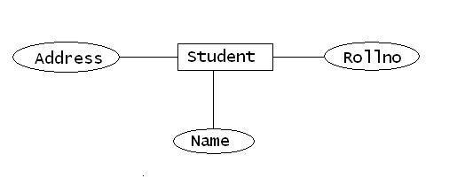

Relationship among data:
A relationship is defined as “an association among entities”. A relationship type is an association of entity types. While a relationship instance is an association of entity instances.
A relationship may associate an entity with itself. Several relationships may exist between the same entities.

The three different types of relationships recognized among various data stored in the database are:
- One-to-one
- One-to-Many( or Many-to-One)
- Many-to-Many

One-to-One:
Consider for example a set of students in a class. Each student can have only one Roll number. Similarly each role number can be associated with on student. This is the case of a one-to-one relationship.
Student1
Assigned
Rollno1
Student2
Assigned
Rollno2

Many-to-One:
One student can register for only one particular course at a time, whereas a number of students could register for the same course.
Student1
Student2
Student3
Register
Course

Many-to-Many:
A vendor can sell a number of items and many vendors can sell a particular item.
Vendor1
Vendor2
Item1
Item2

Database models:
A database model is a theory or specification describing how a database is structured and used. Several such models have been suggested.
Common models include:
- File Management System model
- Hierarchical model
- Network model
- Relational model
- Object-relational model

File Management System Model:
The File Management model was the first method used to store data in a computerized database. The data item is stored sequentially in one large file. A particular relationship cannot be drawn between the items other than the sequence in which it is stored. If a particular data item has to be located, the search starts at beginning and items are checked sequentially till the required item is found.
Disadvantages:
Locating and retrieving a record is a very tedious process because of its sequential access method. Altering the file structure such as updating a record is also cumbersome. To do this task the entire file has to be read and rewritten. It involves writing the new data item into a temporary file, adding this item as a last filed of each record, deleting the original file and renaming the temporary file.

Hierarchical model:
In this model data storage is in the form of a parent-child relationship. The origin of a data tree is the root. Data located at different levels along a particular branch from the root is called the node. The last node in the leaf is called the leaf. This model supports One-to-Many relationship.
Hierarchical structures were widely used in the early mainframe database management systems, such as the Information Management System (IMS) by IBM, and now describe the structure of XML documents.

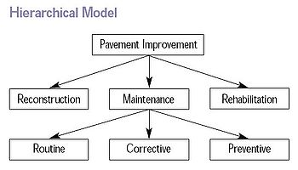

Suppose information is required, say 2.1. It is not necessary for the DBMS to search the entire file to locate the data. Instead, it first follows the level2 branch and fetches the data.
Disadvantages:
It is not possible to enter a new level into the system. As and when such a need arises the entire structure has to be revamped. Another disadvantage is that this model does not support Many-to-Many relationship.

Network model:
The network model (defined by the CODASYL specification) organizes data using two fundamental constructs, called records and sets. Records contain fields (which may be organized hierarchically, as in the programming language COBOL). Sets (not to be confused with mathematical sets) define one-to-many relationships between records: one owner, many members. A record may be an owner in any number of sets, and a member in any number of sets.

The network model is a variation on the hierarchical model, to the extent that it is built on the concept of multiple branches (lower-level structures) emanating from one or more nodes (higher-level structures), while the model differs from the hierarchical model in that branches can be connected to multiple nodes. The network model is able to represent redundancy in data more efficiently than in the hierarchical model.
The operations of the network model are navigational in style: a program maintains a current position, and navigates from one record to another by following the relationships in which the record participates. Records can also be located by supplying key values.
Although it is not an essential feature of the model, network databases generally implement the set relationships by means of pointers that directly address the location of a record on disk. This gives excellent retrieval performance, at the expense of operations such as database loading and reorganization.

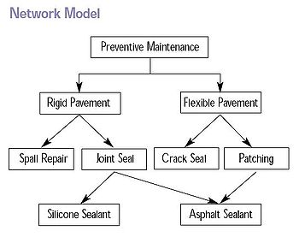

Disadvantages:
The use of pointers leads to complexity in the structure. As a result of the increased complexity mapping of related data becomes very difficult.

Relational model:
The relational model was introduced by E.F.Codd in 1970 as a way to make database management systems more independent of any particular application. It is a mathematical model defined in terms of predicate logic and set theory.
The products that are generally referred to as relational databases in fact implement a model that is only an approximation to the mathematical model defined by Codd.
Three key terms are used extensively in relational database models: relations, attributes, and domains.
A relation is a table with columns and rows. The named columns of the relation are called attributes, and the domain is the set of values the attributes are allowed to take.
The basic data structure of the relational model is the table, where information about a particular entity (say, an employee) is represented in rows (also called tuples) and columns. Thus, the "relation" in "relational database" refers to the various tables in the database; a relation is a set of tuples. The columns enumerate the various attributes of the entity (the employee's name, address or phone number, for example), and a row is an actual instance of the entity (a specific employee) that is represented by the relation. As a result, each tuple of the employee table represents various attributes of a single employee.
All relations (and, thus, tables) in a relational database have to adhere to some basic rules to qualify as relations. First, the ordering of columns is immaterial in a table. Second, there can't be identical tuples or rows in a table. And third, each tuple will contain a single value for each of its attributes.
A relational database contains multiple tables, each similar to the one in the "flat" database model. One of the strengths of the relational model is that, in principle, any value occurring in two different records (belonging to the same table or to different tables), implies a relationship among those two records. Yet, in order to enforce explicit integrity constraints, relationships between records in tables can also be defined explicitly, by identifying or non-identifying parent-child relationships characterized by assigning cardinality (1:1, (0)1:M, M:M). Tables can also have a designated single attribute or a set of attributes that can act as a "key", which can be used to uniquely identify each tuple in the table.
A key that can be used to uniquely identify a row in a table is called a primary key. Keys are commonly used to join or combine data from two or more tables. For example, an Employee table may contain a column named Location which contains a value that matches the key of a Location table. Keys are also critical in the creation of indexes, which facilitate fast retrieval of data from large tables. Any column can be a key, or multiple columns can be grouped together into a compound key. It is not necessary to define all the keys in advance; a column can be used as a key even if it was not originally intended to be one.

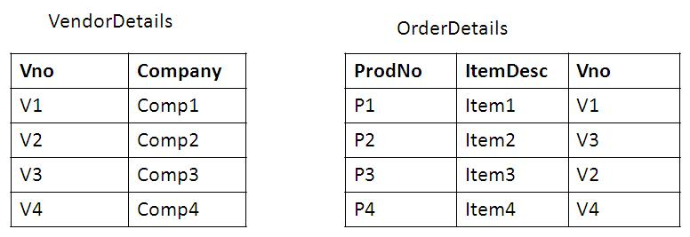

Object-Relational Model:
An object-relational database (ORD), or object-relational database management system (ORDBMS), is a database management system (DBMS) similar to a relational database, but with an object-oriented database model: objects, classes and inheritance are directly supported in database schemas and in the query language. In addition, it supports extension of the data model with custom data-types and methods.

MS SQL SERVER

SQL Server 2008 R2:
SQL Server 2008 R2 (formerly codenamed SQL Server "Kilimanjaro") was announced at TechEd 2009, and was released to manufacturing on April 21, 2010. SQL Server 2008 R2 adds certain features to SQL Server 2008 including master data management system branded as Master Data Services, a centralized console to manage multiple SQL Server instances, and support for more than 64 logical processors.
SQL Server 2008 R2 boasts a number of new services, including PowerPivot for Excel and SharePoint, Master Data Services, StreamInsight, ReportBuilder 3.0, Reporting Services Add-in for SharePoint, a Data-tier function in Visual Studio that enables packaging of tiered databases as part of an application, and a SQL Server Utility named UC (Utility Control POint), part of AMSM (Application and Multi-Server Management) that is used to manage multiple SQL Servers.

SQL Server 2012:

At the 2011 Professional Association for SQL Server (PASS) summit on October 11, Microsoft announced that the next major version of SQL Server (codenamed "Denali"), would be SQL Server 2012. It was released to manufacturing on March 6, 2012.
It was announced to be last version to natively support OLE DB and instead to prefer ODBC for native connectivity. This announcement has caused some controversy.
SQL Server 2012's new features and enhancements include AlwaysOn SQL Server Failover Cluster Instances and Availability Groups which provides a set of options to improve database availability, Contained Databases which simplify the moving of databases between instances, new and modified Dynamic Management Views and Functions, programmability enhancements including new Spatial features, Metadata discovery, Sequence objects and the THROW statement, performance enhancements such as ColumnStore Indexes as well as improvements to OnLine and Partition level operations and security enhancements including Provisioning During Setup, new permissions, improved role management and default schema assignment for groups.

SQL Server 2014:
SQL Server 2014 was released to manufacturing on March 18, 2014, and released to the general public on April 1, 2014. Until November, 2013 there were two CTP revisions, CTP1 and CTP2. SQL Server 2014 provides a new in-memory capability for tables that can fit entirely in memory (also known as Hekaton). Whilst small tables may be entirely resident in memory in all versions of SQL Server, they also may reside on disk, so work is involved in reserving RAM, writing evicted pages to disk, loading new pages from disk, locking the pages in RAM while they are being operated on, and many other tasks. By treating a table as guaranteed to be entirely resident in memory much of the 'plumbing' of disk-based databases can be avoided.
For disk-based SQL Server applications, it also provides SSD bufferpool extension, which can improve application performance transparently by leveraging SSD as the intermediate memory hierarchy between DRAM and spinning media.
SQL Server 2014 also enhances AlwaysOn (HADR) solution by increasing the readable secondaries count and sustaining read operations upon secondary-primary disconnections, and it provides new hybrid disaster recovery and backup solutions with Windows Azure, enabling customers to use their existing skills with the on-premises product offerings to take advantage of Microsoft's global datacenters. In addition, it takes advantage of new Windows Server 2012 and Windows Server 2012 R2 capabilities for database application scalability in a physical or virtual environment.

Editions of SQL Server 2014:
Microsoft makes SQL Server available in multiple editions, with different feature sets and targeting different users. These editions are:

SQL Server Compact Edition (SQL CE):
The compact edition is an embedded database engine. Unlike the other editions of SQL Server, the SQL CE engine is based on SQL Mobile (initially designed for use with hand-held devices) and does not share the same binaries. The 3.5 version includes considerable work that supports ADO.NET Synchronization Services.
SQL Server Evaluation Edition:
SQL Server Evaluation Edition, also known as the Trial Edition, has all the features of the Enterprise Edition, but is limited to 180 days, after which the tools will continue to run, but the server services will stop.^{[24]}
SQL Server Express Edition:
SQL Server Express Edition is a scaled down, free edition of SQL Server, which includes the core database engine. While there are no limitations on the number of databases or users supported, it is limited to using one processor, 1 GB memory and 4 GB database files (10 GB database files from SQL Server Express 2008 R2).

SQL Server Fast Track:
SQL Server Fast Track is specifically for enterprise-scale data warehousing storage and business intelligence processing, and runs on reference-architecture hardware that is optimized for Fast Track.

SQL Server Standard Edition:
SQL Server Standard edition includes the core database engine, along with the stand-alone services. It differs from Enterprise edition in that it supports fewer active instances (number of nodes in a cluster) and does not include some high-availability functions such as hot-add memory (allowing memory to be added while the server is still running), and parallel indexes.

SQL Server Developer Edition:
SQL Server Developer Edition includes the same features as SQL Server Enterprise Edition, but is limited by the license to be only used as a development and test system, and not as production server. This edition is available to download by students free of charge as a part of Microsoft's Dreams park program.

SQL Server Enterprise Edition:
SQL Server Enterprise Edition is the full-featured edition of SQL Server, including both the core database engine and add-on services, while including a range of tools for creating and managing a SQL Server cluster.

SQL Server Web Edition:
SQL Server Web Edition is a low-TCO option for Web hosting.

SQL Server Workgroup Edition:
SQL Server Workgroup Edition includes the core database functionality but does not include the additional services.

Tools:

SQLCMD:
SQLCMD is a command line application that comes with Microsoft SQL Server, and exposes the management features of SQL Server. It allows SQL queries to be written and executed from the command prompt. It can also act as a scripting language to create and run a set of SQL statements as a script. Such scripts are stored as a .sql file, and are used either for management of databases or to create the database schema during the deployment of a database.
SQLCMD was introduced with SQL Server 2005 and this continues with SQL Server 2008. Its predecessor for earlier versions was OSQL and ISQL, which is functionally equivalent as it pertains to TSQL execution, and many of the command line parameters are identical, although SQLCMD adds extra versatility.

Visual Studio:
Microsoft Visual Studio includes native support for data programming with Microsoft SQL Server. It can be used to write and debug code to be executed by SQL CLR. It also includes a data designer that can be used to graphically create, view or edit database schemas. Queries can be created either visually or using code. SSMS 2008 onwards, provides intellisense for SQL queries as well.

SQL Server Management Studio:
SQL Server Management Studio is a GUI tool included with SQL Server 2005 and later for configuring, managing, and administering all components within Microsoft SQL Server. The tool includes both script editors and graphical tools that work with objects and features of the server.
SQL Server Management Studio replaces Enterprise Manager as the primary management interface for Microsoft SQL Server since SQL Server 2005. A version of SQL Server Management Studio is also available for SQL Server Express Edition, for which it is known as SQL Server Management Studio Express (SSMSE).
A central feature of SQL Server Management Studio is the Object Explorer, which allows the user to browse, select, and act upon any of the objects within the server. It can be used to visually observe and analyze query plans and optimize the database performance, among others.
SQL Server Management Studio can also be used to create a new database, alter any existing database schema by adding or modifying tables and indexes, or analyze performance. It includes the query windows which provide a GUI based interface to write and execute queries.

Business Intelligence Development Studio:
Business Intelligence Development Studio (BIDS) is the IDE from Microsoft used for developing data analysis and Business Intelligence solutions utilizing the Microsoft SQL Server Analysis Services, Reporting Services and Integration Services. It is based on the Microsoft Visual Studio development environment but customizes with the SQL Server services-specific extensions and project types, including tools, controls and projects for reports (using Reporting Services), Cubes and data mining structures (using Analysis Services).

SQL Server Services:

SQL Server also includes an assortment of add-on services. While these are not essential for the operation of the database system, they provide value added services on top of the core database management system. These services either run as a part of some SQL Server component or out-of-process as Windows Service and presents their own API to control and interact with them.

Service Broker:
Used inside an instance, it is used to provide an asynchronous programming environment. For cross instance applications, Service Broker communicates The Service Broker, which runs as a part of the database engine, provides a reliable messaging and message queuing platform for SQL Server applications.

Replication Services:
SQL Server Replication Services are used by SQL Server to replicate and synchronize database objects, either in entirety or a subset of the objects present, across replication agents, which might be other database servers across the network, or database caches on the client side. Replication follows a publisher/subscriber model, i.e., the changes are sent out by one database server ("publisher") and are received by others ("subscribers"). SQL Server supports three different types of replication:
Transaction replication
Each transaction made to the publisher database (master database) is synced out to subscribers, who update their databases with the transaction. Transactional replication synchronizes databases in near real time.
Merge replication
Changes made at both the publisher and subscriber databases are tracked, and periodically the changes are synchronized bi-directionally between the publisher and the subscribers. If the same data has been modified differently in both the publisher and the subscriber databases, synchronization will result in a conflict which has to be resolved - either manually or by using pre-defined policies.
Snapshot replication
Snapshot replication published a copy of the entire database (the then-snapshot of the data) and replicates out to the subscribers. Further changes to the snapshot are not tracked.

Analysis Services:
SQL Server Analysis Services adds OLAP and data mining capabilities for SQL Server databases. The OLAP engine supports MOLAP, ROLAP and HOLAP storage modes for data. Analysis Services supports the XML for Analysis standard as the underlying communication protocol. The cube data can be accessed using MDX queries. Data mining specific functionality is exposed via the DMX query language.

Reporting Services:
SQL Server Reporting Services is a report generation environment for data gathered from SQL Server databases. It is administered via a web interface. Reporting services features a web services interface to support the development of custom reporting applications. Reports are created as RDL files.
Reports can be designed using recent versions of Microsoft Visual Studio (Visual Studio.NET 2003, 2005, and 2008) with Business Intelligence Development Studio, installed or with the included Report Builder. Once created, RDL files can be rendered in a variety of formats including Excel, PDF, CSV, XML, TIFF (and other image formats), and HTML Web Archive.

Notification Services:
Originally introduced as a post-release add-on for SQL Server 2000, Notification Services was bundled as part of the Microsoft SQL Server platform for the first and only time with SQL Server 2005. With Sql Server 2005, SQL Server Notification Services is a mechanism for generating data-driven notifications, which are sent to Notification Services subscribers. A subscriber registers for a specific event or transaction (which is registered on the database server as a trigger); when the event occurs, Notification Services can use one of three methods to send a message to the subscriber informing about the occurrence of the event. These methods include SMTP, SOAP, or by writing to a file in the file system. Notification Services was discontinued by Microsoft with the release of SQL Server 2008 in August 2008, and is no longer an officially supported component of the SQL Server database platform.

Integration Services:
SQL Server Integration Services is used to integrate data from different data sources. It is used for the ETL capabilities for SQL Server for data warehousing needs. Integration Services includes GUI tools to build data extraction workflows integration various functionality such as extracting data from various sources, querying data, transforming data including aggregating, duplication and merging data, and then loading the transformed data onto other sources, or sending e-mails detailing the status of the operation as defined by the user.
Programmability:

T-SQL:
T-SQL (Transact-SQL) is the primary means of programming and managing SQL Server. It exposes keywords for the operations that can be performed on SQL Server, including creating and altering database schemas, entering and editing data in the database as well as monitoring and managing the server itself. Client applications, both which consume data or manage the server, leverage SQL Server functionality by sending T-SQL queries and statements which are then processed by the server and results (or errors) returned to the client application. SQL Server allows it to be managed using T-SQL. For this it exposes read only tables from which server statistics can be read. Management functionality is exposed via system-defined stored procedures which can be invoked from T-SQL queries to perform the management operation. It is also possible to create linked Server using T-SQL. Linked server allows operation to multiple server as one query.

SQL Native Client:
SQL Native Client is the native client side data access library for Microsoft SQL Server, version 2005 onwards. It natively implements support for the SQL Server features including the Tabular Data Stream implementation, support for mirrored SQL Server databases, full support for all data types supported by SQL Server, asynchronous operations, query notifications, encryption support, as well as receiving multiple result sets in a single database session. SQL Native Client is used under the hood by SQL Server plug-ins for other data access technologies, including ADO or OLE DB. The SQL Native Client can also be directly used, bypassing the generic data access layers.

STRUCTURED QUERY LANGUAGE

SQL is a standard that every database should follow. That means all the SQL commands should work in all databases. Based on the type of operations we are performing on the database, SQL is divided into the following types:

- Data Definition Language (DDL)
- Data Query Language(DQL)
- Data Manipulation Language (DML)
- Transaction Control Language (TCL)
- Data Control Language (DCL)

Data Definition Language:
It is used to create an object (e.g. table), alter the structure of an object and also to delete the object from the server. All these commands will effect only the structure of the database object. The commands contained by this language are:
- CREATE - used to create an object
- ALTER - used to modify an existing object
- DROP - used to delete the object
- TRUNCATE - used to delete only the data of an object

Note: DDL commands are AUTO COMMIT. i.e., with the execution of these commands, the results will be stored directly into the database.

Data Query Language:
The DQL Command will be used to retrieve data from the objects.
- SELECT - used to query the object data

Data Manipulation Language:
The DML commands are most frequently used SQL commands. They are used to query and manipulate existing objects like tables. They should affect only the data of an existing structure. The commands existing in this language are:
- INSERT - used to enter the data into the object
- UPDATE - used to modify existing objects data
- DELETE - used to delete the data of an object.

Transaction Control Language:

A transaction is a logical unit of work. All changes made to the database can be referred to as a transaction.Whenever, we perform a DML operation, results will be stored in the buffer not in the database. The user can control Transaction changes with the use of this language commands. They are:
- COMMIT - used to make the changes permanent
- ROLLBACK - used to undo the changes
DDL
DMLL
Database
Buffer
Query Editor
Commit
Rollback

Data Control Language:
In general to access an object which was created by another user, at first, we must get the permission from the owner of the object. To provide the permission or remove the permission, we use this language commands. They are:
- GRANT - Used to provide Permission
- REVOKE - Used to remove the Permission

DATABASES

A database in Microsoft SQL Server consists of a collection of tables that contain data and other objects, such as views, indexes, stored procedures, and triggers, defined to support activities performed with the data. The data stored in a database is usually related to a particular subject or process, such as inventory information for a manufacturing warehouse.
SQL Server can support many databases. Each database can store either interrelated or unrelated data from other databases. For example, a server can have one database that stores personnel data and another that stores product-related data. Alternatively, one database can store current customer order data, and another related database can store historical customer orders used for yearly reporting.

Database Architecture:
Microsoft SQL Server 2014 data is stored in databases. The data in a database is organized into the logical components visible to users. A database is also physically implemented as two or more files on disk.
When using a database, you work primarily with the logical components such as tables, views, procedures, and users. The physical implementation of files is largely transparent. Typically, only the database administrator needs to work with the physical implementation.

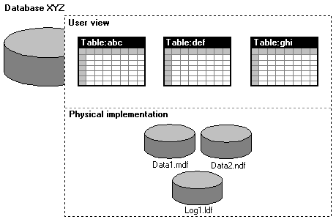

Each instance of SQL Server has four system databases (master, model, tempdb, and msdb) and one or more user databases. Some organizations have only one user database, containing all the data for their organization. Some organizations have different databases for each group in their organization, and sometimes a database used by a single application. For example, an organization could have one database for sales, one for payroll, one for a document management application, and so on. Sometimes an application uses only one database; other applications may access several databases.

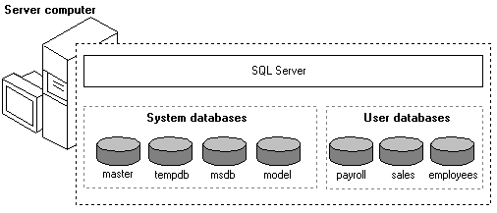

It is not necessary to run multiple copies of the SQL Server database engine to allow multiple users to access the databases on a server. An instance of the SQL Server Standard or Enterprise Edition is capable of handling thousands of users working in multiple databases at the same time. Each instance of SQL Server makes all databases in the instance available to all users that connect to the instance, subject to the defined security permissions.

Types of Databases:
SQL Server provides two types of Databases.
- System Databases
- User Defined Databases

System Databases:
Along with the installation of SQL Server FOUR databases will be created automatically called as system databases. They can be used by any user anywhere from SQL Server.
The System Databases are:
- master
The master database records all of the system level information for a SQL Server system. It records all login accounts and all system configuration settings. master is the database that records the existence of all other databases, including the location of the database files. master records the initialization information for SQL Server; always have a recent backup of master available.
- model
The model database is used as the template for all databases created on a system. When a CREATE DATABASE statement is issued, the first part of the database is created by copying in the contents of the model database, then the remainder of the new database is filled with empty pages. Because tempdb is created every time SQL Server is started, the model database must always exist on a SQL Server system.
- msdb
The msdb database is used by SQL Server Agent for scheduling alerts and jobs, and recording operators.
- tempdb
tempdb holds all temporary tables and temporary stored procedures. It also fills any other temporary storage needs such as work tables generated by SQL Server. tempdb is a global resource; the temporary tables and stored procedures for all users connected to the system are stored there. tempdb is re-created every time SQL Server is started so the system starts with a clean copy of the database

User Defined Databases:
The databases that are created by the users are called as user defined databases.
While creating a database, the user has to specify a name to the database and the details of data files, which are used to specify the location, where the database data is to be stored.

Files and Filegroups:
Microsoft® SQL Server™ 2000 maps a database using a set of operating-system files. All data and objects in the database, such as tables, stored procedures, triggers, and views, are stored within these operating-system files:
- Primary Data File (.mdf)
This file contains the startup information for the database and is used to store data. Every database has one primary data file.
- Secondary Data File (.ndf)
These files hold all of the data that does not fit in the primary data file. If the primary file can hold all of the data in the database, databases do not need to have secondary data files. Some databases may be large enough to need multiple secondary data files or to use secondary files on separate disk drives to spread data across multiple disks.
- Transaction Log File (.ldf)
These files hold the log information used to recover the database. There must be at least one log file for each database.
Filegroups allow files to be grouped together for administrative and data allocation/placement purposes. For example, three files (Data1.ndf, Data2.ndf, and Data3.ndf) can be created on three disk drives, respectively, and assigned to the filegroup fgroup1. A table can then be created specifically on the filegroup fgroup1. Queries for data from the table will be spread across the three disks, thereby improving performance. Files and filegroups, however, allow you to easily add new files on new disks. Additionally, if your database exceeds the maximum size for a single Microsoft Windows NT® file, you can use secondary data files to allow your database to continue to grow.

Creating a Database:
To create a database, determine the name of the database, its owner (the user who creates the database), its size, and the files and filegroups used to store it.
Before creating a database, consider that:
- Permission to create a database defaults to members of the sysadmin and dbcreator fixed server roles.
- The user who creates the database becomes the owner of the database.
- A maximum of 32,767 databases can be created on a server.
- The name of the database must follow the rules for identifiers.

Creating Database using Navigation:
- Open the 'Management Studio’ tool and connect to the required instance of SQL Server with desired authentication.

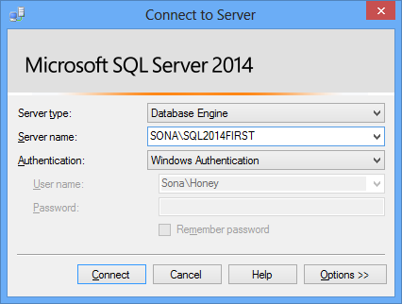

2. Expand ‘Databases’ Item. It displays list of already existing databases.
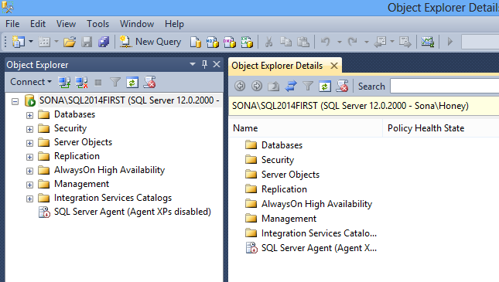

3. Right Click on the ‘Databases’ item and select ‘New Database’ option.
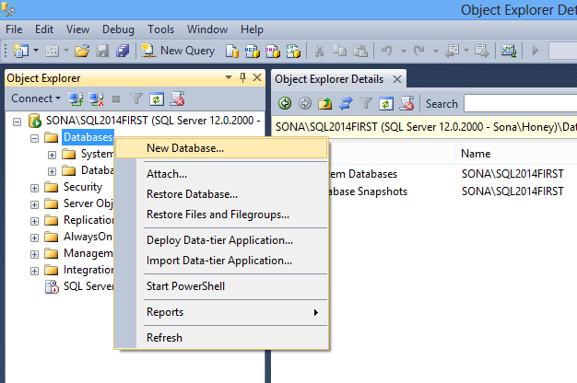

4. Provide a name to the Database and specify the details of primary and log file and ‘Database Files’ section.
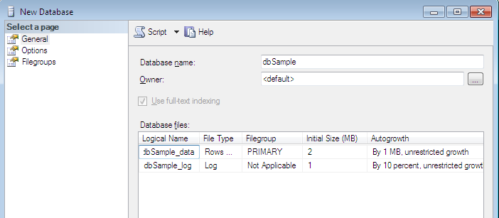

Creating a Database Using a Query:

Once the Query Analyzer is opened, in the command window we can write any command that has to be executed.
Syntax:
CREATE DATABASE databasename
[ON]
(NAME=<logical file name>,
FILENAME=<os-filename>,
SIZE=<in mb’s>,MAXSIZE=<in mb’s>,FILEGROWTH=<in mb’s>)]
[LOG ON
(NAME=<logical file name>,
FILENAME=<os-filename>,
SIZE=<in mb’s>,MAXSIZE=<in mb’s>,FILEGROWTH=<in mb’s>)]

Note: ‘Logicalfilename’ is used to identity the file for further modifications and ‘os-filename’ refers the original location where the file is stored in the hard disk.

Example: 1. Creating a database without specifying Data Files
CREATE DATABASE dbNew

Note: Creates a database called ‘dbNew’ with a size of 1.68MB. It internally contains a default primary file of 1216KB and log file of 504KB.
Example: 2. Creating a database Data Files
CREATE DATABASE dbSample
ON
(NAME=’dbSampleData,
FILENAME=’d:\backup\data\dbSample_data.mdf’,
SIZE=20,MAXSIZE=50,FILEGROWTH=5)
LOG ON
(NAME=dbSampleLog’,
FILENAME=’d:\backup\log\dbSample_log.ldf’,
SIZE=10,MAXSIZE=25,FILEGROWTH=5)

Modifying the Database:
The changes that can be made to existing database are
- The data and log files can be added or removed.
- The database can be made to expand or shrink
- File groups can be added and removed from the database.
- The configuration settings for the database can be changed

The database can be expanded by allocating additional space to the existing database file or by allocating space to a new file. The size of the database must be increased by at least 1mb.

A maximum size should be specified using the MAXSIZE parameter of the ALTER DATABASE statement. This prevents the file from growing until the disk space is exhausted.
Syntax:
ALTER DATABASE <database Name>
ADD FILE <file specifications>
|ADD LOG FILE <file specifications>
|REMOVE FILE <file name>
|ADD FILEGROUP <file group name>
|REMOVE FILEGROUP <file group name>
|MODIFY FILE <file specifications>
|MODIFY FILEGROUP <file group name>

Example:
ALTER DATABASE dbSample
ADD FILE
(NAME= ‘dbSampledata1’,
FILE NAME=’d:\backup\data\dbSample_data1.ndf’,
SIZE=10mb,
MAXSIZE=30mb,
FILEGROWTH=1mb)

To add a file group:

ALTER DATABASE dbSample
ADD FILEGROUP frgp1
To attach new files to new file group:

To add a secondary file in the file group:
ALTER DATABASE dbSample
ADD FILE
(NAME= ‘dbsample2_dat’,
FILE NAME=’d:\backup\data\dbSample2_dat.mdf’,
SIZE=4mb,MAXSIZE=30mb,FILEGROWTH=1mb)
TO FILEGROUP frgp1

Viewing The Database:
The information regarding the database such as owner, size, date and time of creation, status can be viewed using the following System Stored Procedure:
Syntax:
Sp_helpdb ‘database name’

Example:
sp_helpdb emp

NOTE: The sp_helpdb system stored procedure without a database name reports information about all the databases in the system.

Database options can be changed or displayed using:
Syntax:
Sp_dboption ‘database name’, ‘option name’, TRUE/FALSE

Different options that can be set to database are:
Dbuseonly – only owner of the database can use it.

Offline – the database is offline when this option is set.

Readonly – data can only read in the database

Select into/bulk copy – faster bulk copy

Single user – only one user can use it

Example:
sp_dboption ‘dbSample’, ‘readonly’, TRUE

Renaming the database:
The name of the database can be changed as:
Syntax:
sp_renamedb ‘old name’, ‘new name’
Example:
sp_renamedb ‘dbSample ’, ’SampleDB’

Deleting the database:
Syntax:
DROP DATABASE <database name>

Example:
DROP DATABASE dbSample

TABLES

TABLES
Tables are database objects that contain all the data in a database. A table definition is a collection of columns. In tables, data is organized in a row-and-column format similar to a spreadsheet. Each row represents a unique record, and each column represents a field within the record.
After you have designed the database, the tables that will store the data in the database can be created. The data is usually stored in permanent tables. Tables are stored in the database files until they are deleted and are available to any user who has the appropriate permissions.
Types of Tables:
Corresponding to the type of data we are storing inside the tables, they are divided into the following ways:
- System Tables
- User Tables
- Temporary Tables
System Tables:
These are the tables that will come along with the SQL Server database installation. All these tables will be stored under Master database. They will provide System level information. Ex: sysobjects, sysusers etc.,

User Tables:
These are the tables that are created by a user. The user who creates the table will be the owner for that table. In order to get an access to that table, other users must get corresponding permission from the owner of the table.

Temporary Tables
You can also create temporary tables. Temporary tables are similar to permanent tables, except temporary tables are stored in tempdb and are deleted automatically when no longer in use. They will be identified by “#” symbol.

Table Properties
You can define up to 1,024 columns per table. Table and column names must follow the rules for identifiers; they must be unique within a given table, but you can use the same column name in different tables in the same database. You must also define a data type for each column.
Although table names must be unique for each owner within a database, you can create multiple tables with the same name if you specify different owners for each.
Creating a Table using Navigation:
- Open the ‘Management Studio’ tool and navigate up to the database where we want to create the table.
- Expand ‘Tables’ item that displays list of existing tables.
- Right click on ‘Tables’ item and select ‘New Table’ option.
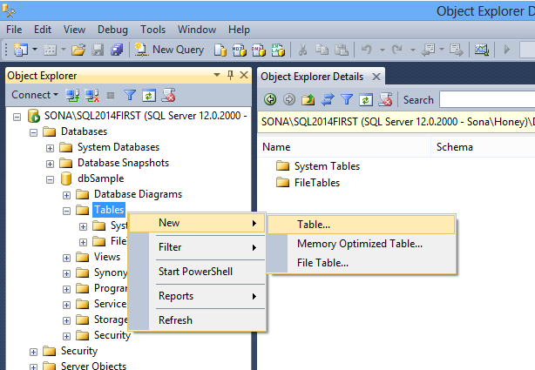
- In the ‘Data Grid’ displayed enter the details of columns such as – column name, data type, size.
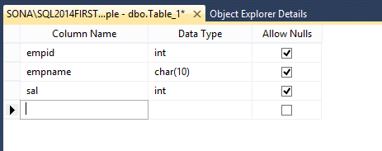
- Click on the ‘Save’ icon of the toolbar to provide tablename. Ex:Emp

Creating a Table using Query:
We can make use of the following syntax to create a table:
CREATE TABLE tablename
(colname datatype (size) [NOT NULL | DEFAULT <constant value> | IDENTITY(seed,increment)], colname2 ……..)

NULL | NOT NULL:
Are keywords that determine if null values are allowed in the column. NULL is not strictly a constraint but can be specified in the same manner as NOT NULL.
DEFAULT:
Specifies the value to be provided for the column when a value is not explicitly supplied during an insert.
constant_expression
Is a constant, NULL, or a system function used as the default value for the column.
IDENTITY:
Indicates that the new column is an identity column. When a new row is added to the table, Microsoft® SQL Server™ provides a unique, incremental value for the column. The IDENTITY property can be assigned to tinyint, smallint, int, bigint, decimal(p,0), or numeric(p,0) columns. Only one identity column can be created per table. Bound defaults and DEFAULT constraints cannot be used with an identity column. You must specify both the seed and increment or neither. If neither is specified, the default is (1,1).
seed
Is the value used for the very first row loaded into the table.
increment
Is the incremental value added to the identity value of the previous row loaded.
- A table can have only one column defined with the IDENTITY property
- The seed and increment can be specified. The default for both is 1
- The identifier column must not allow NULL values and must not contain DEFAULT definition
- In order to insert the values explicitly into the identity column , SET IDENTITY_INSERT option is used.

Example:

- Select the corresponding database in which we want to create the table from the available drop down button.
- Type the following command in the query window.
CREATE TABLE employee
( empid VARCHAR(5),
Ename char(10), basic_sal int DEFAULT 10000
)

- click on Execute button to run the command.

Example 2: Crating a table with identity column
CREATE TABLE dept
( dno int identity (10,1),
dept_name varchar(20)
)

When an IDENTITY property to define an identifier column, consider that:

Syntax:
SET IDENTITY_INSERT tablename ON | OFF

Modifying Tables:
After a table is created, you can change many of the options that were defined for the table when it was originally created, including:
- Columns can be added, modified, or deleted. For example, the column name, length, data type, precision, scale, and nullability can all be changed, although some restrictions exist. For more information.
- PRIMARY KEY and FOREIGN KEY constraints can be added or deleted.
- UNIQUE and CHECK constraints and DEFAULT definitions (and objects) can be added or deleted.
- An identifier column can be added or deleted using the IDENTITY or ROWGUIDCOL property.

Renaming a Table:

Syntax:
SP_RENAME <old_tableName>,<new_tableName>

Example:
SP_RENAME employee.emp

Renaming a Column:
Syntax:
SP_RENAME <’ tableName.columnname’>,<’newcolName’>

Example:
SP_RENAME ‘emp.basic_salary’,’sal’

Syntax for ALTER TABLE command:
ALTER TABLE tablename
ADD columnName datatype [not null |identity|default…]
|ALTER COLUMN <column specifications>
|DROP COLUMN columnName
|ADD CONSTRAINT constraintName {CHECK(..) | UNIQUE | PRIMARY KEY..}
|DROP CONSTRAINT constraintName

Examples:

Changing datatype
ALTER TABLE emp ALTER COLUMN empid int

Changing NULLs
ALTER TABLE emp ALTER COLUMN empid int NOT NULL

Adding Columns

ALTER TABLE emp ADD dno int

Sp_help:
This System Stored Procedure is used to provide description about the table structure.
Example:
SP_HELP emp

Entering Table Data:
The Insert command is used to add rows to a table. If we are entering entire table data then it is optional to specify the column list. Where as if we are entering only particular column details or the order of columns then we must specify the column list.

Syntax:
INSERT INTO <table_name>[ (column_list)] VALUES (data_list)

Example:
- INSERT INTO emp (empid,ename,sal,dno)
VALUES(1,’E1’,25000,20)
- INSERT INTO emp values(2,’E2’,30000,10)

- If we want to insert only certain columns data into the table, the column names have to be specified.
Example:
3. INSERT INTO emp ( empid,ename,dno) VALUES(3,’E3’,20)

It is also possible to enter multiple records at a time into the table.
4. INSERT INTO emp
Select 4,’E4’,15000,10 UNION ALL
Select 5,’E5’,30000,30

Retrieving Table Data:
The SELECT statement is used to retrieve the data from the table. It is possible to retrieve all the table data or particular column data. In order to retrieve complex data from the tables, we can add extra optional clauses to the select statement.
Note: A maximum of 4096 columns can be specified in a select statement.
Syn:
SELECT <column list> FROM <tablename>
[WHERE <condition>
[GROUP BY <column name>]
[HAVING <Condition based on the grouped data>]
[ORDER BY <column name> [ASC | DESC] ]

Ex:
- Select * from emp
- Select empid,ename,sal,dno from emp
- Select count(*) from emp

WHERE Clause:
It is used to provide a condition in the select statement. Only those records that satisfy the condition will be displayed as output. The condition can be specified based on any column of the table.
Ex:
Q: Get the details of employees who belongs to the department
20 and also having more than 20000 salary.
Sol:
Select * from emp
Where dno=20 AND sal>20000

Output:
Empid ename sal dno
1 E1 25000 20

GROUP BY Clause:
It is used to group the table data based on a column. After grouping the table data, we can able to apply an aggregate function on each group independently. The aggregations include: COUNT, MIN, MAX, AVG and SUM.
Ex:
Q.1: Get the no.of employees in each department.
Sol:
SELECT dno,count(*) from emp
GROUP BY dno

Output:
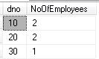
Q.2: Get the total amount paying to each department
Sol:
SELECT dno,SUM(sal) from emp
GROUP BY dno

Output:
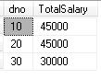

HAVING Clause:
Like a ‘Where’ clause, HAVING clause is also used to provide condition based on the grouped data. The difference between them is :
With WHERE clause, condition can be specified on entire column data at a time. i.e., before grouping the table data. Whereas, with HAVING clause the condition can be specified after grouping the table data on each group independently.
When to use which clause depends on the criteria of the query. If the criteria doesn’t require grouping, use where clause other wise use having clause.
Examples:
Q.1: Get the no.of employees in each department with employees having more than 25000
Sol:
SELECT dno,Count(*) NoOfEmployees from emp
WHERE sal>25000 GROUP BY dno

Output:

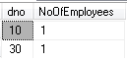
Q.2: Get the department which are having more than one employee
Sol:
SELECT dno,Count(*) NoOfEmployees from emp
GROUP BY dno HAVING count(dno)>1

Output:
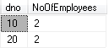

Modifying Table Data:
To modify the values stored in a table, UPDATE statement is used. We can able to modify either a single column or multiple column data and a single record or multiple records data.
Syntax:
UPDATE <TableName> SET <col1>=Val1 [, Col2=val2,…..]
[WHERE <condition>]

Example: the employee name Samuel with the emp_no “E001” was wrongly entered as ‘A’ in the table. To correct it, the following statement is used.
UPDATE emp
SET ename=’Samuel’
WHERE empid=1

Deleting data from a Table:
To remove rows from a table, DELETE or TRUNCATE statements can be used.
To delete a particular row from the table we have to use DELETE command.
Syntax:
DELETE FROM tablename WHERE condition

Example:
DELETE FROM emp WHERE emp_no=’E002’

To delete all rows from the table, TRUNCATE command can also be used.
Syntax:
TRUNCATE TABLE tablename

Example:
TRUNCATE TABLE emp

The TRUNCATE statement removes the whole table at a time. Whereas the delete table command removes each row from the table one by one. This is much faster than a DELETE statement, especially on large tables.

Removing The Table:
To remove the table along with the structure, DROP statement is used.
Syntax:
DROP TABLE tablename

Example:
DROP TABLE dept1

DATATYPES

The choice of the datatype determines the kind of data that can be stored in the column and the maximum length of data that can be stored in the column. SQL Server provides different categories of data types. They are:
Exact numerics | Unicode character strings
Approximate numerics | Binary strings
Date and time | Other data types
Character strings

In SQL Server, based on their storage characteristics, some data types are designated as belonging to the following groups:
- Large value data types: varchar(max), nvarchar(max), and varbinary(max)
- Large object data types: text, ntext, image, varchar(max), nvarchar(max), varbinary(max), and xml

Exact Numeric Datatypes:

They will be used to store integer data.
Data type | Range | Storage
bigint | -2^63 (-9,223,372,036,854,775,808) to 2^63-1 (9,223,372,036,854,775,807) | 8 Bytes
int | -2^31 (-2,147,483,648) to 2^31-1 (2,147,483,647) | 4 Bytes
smallint | -2^15 (-32,768) to 2^15-1 (32,767) | 2 Bytes
tinyint | 0 to 255 | 1 Byte

Numeric data types that have fixed precision and scale.
decimal[ (p[ , s] )] and numeric[ (p[ , s] )]
Fixed precision and scale numbers. When maximum precision is used, valid values are from - 10^38 +1 through 10^38 - 1. The ISO synonyms for decimal are dec and dec(p, s). numeric is functionally equivalent to decimal.
p (precision)
The maximum total number of decimal digits that can be stored, both to the left and to the right of the decimal point. The precision must be a value from 1 through the maximum precision of 38. The default precision is 18.
s (scale)
The maximum number of decimal digits that can be stored to the right of the decimal point. Scale must be a value from 0 through p. Scale can be specified only if precision is specified. The default scale is 0; therefore, 0 <= s <= p. Maximum storage sizes vary, based on the precision.
Precision | Storage bytes
1 - 9 | 5
10-19 | 9
20-28 | 13
29-38 | 17

Character Datatype:

There are three valid datatypes for storing strings. They are:

Char: this is used for storing fixed-length strings. Columns defined as char will store blanks to fill out a fixed number of characters. The maximum length of a character column is 8000 bytes.

Varchar: this is used for storing variable length strings. Columns defined as varchar will truncate blanks to save space.

Text: this is used for storing of virtually unlimited size(upto 2 gigabytes of text per row.

Binary Datatypes:

These datatypes store strings consisting of binary values.i.e, haxadecima numbers instead of characters. They are:

Binary: Stores binary data of fixed lengh with a maximum lengh of 8,000 bytes

Varbinary: Stores variable lengh binary data with a maximum length of 8,000 bytes

Image: SQL Server provides a mechanism for storing binary data more than 8000 bytes using image datatypes. For Example, the photograph of the employees can be stored.

DateTime Datatype:

SQL Server enables to store date and time values. Columns using datetime or smalldatetime will store both date and time.

Unicode Datatype:

Unicode standard includes all the characters that are defined in the various character sets. Using Unicode data types, a column can store any character that is defined by the Unicode standard. Unicode data is stored using nchar, nvarchar, ntext datatypes.

Special DataTypes:

Cursor:
This data type is used for variables or stored procedure OUTPUT parameters that contain a reference to a cursor. Any variables created with the cursor data type are nullable.
The operations that can reference variables and parameters having a cursor data type are:
- The DECLARE @local_variable and SET @local_variable statements.
- The OPEN, FETCH, CLOSE, and DEALLOCATE cursor statements.
- Stored procedure output parameters.
- The CURSOR_STATUS function.

- The sp_cursor_list, sp_describe_cursor, sp_describe_cursor_tables, and sp_describe_cursor_columns system stored procedures.

NOTE: The cursor data type cannot be used for a column in a CREATE TABLE statement

varchar(max) | varbinary(max)
nvarchar(max) | xml
text | ntext
image | timestamp
sql_variant | User-defined types
hierarchyid
sql_variant can have a maximum length of 8016 bytes. This includes both the base type information and the base type value. The maximum length of the actual base type value is 8,000 bytes.
A sql_variant data type must first be cast to its base data type value before participating in operations such as addition and subtraction.
sql_variant can be assigned a default value. This data type can also have NULL as its underlying value, but the NULL values will not have an associated base type. Also, sql_variant cannot have another sql_variant as its base type.
A unique, primary, or foreign key may include columns of type sql_variant, but the total length of the data values that make up the key of a specific row should not be more than the maximum length of an index. This is 900 bytes.
A table can have any number of sql_variant columns.

Table:
Is a special data type that can be used to store a result set for processing at a later time. table is primarily used is for temporary storage of a set of rows returned as the result set of a table-valued function.
table variables provide the following benefits:
- A table variable behaves like a local variable. It has a well-defined scope. This is the function, stored procedure, or batch that it is declared in.
Within its scope, a table variable can be used like a regular table. It may be applied anywhere a table or table expression is used in SELECT, INSERT, UPDATE, and DELETE statements. However, table cannot be used in the following statement:
SELECT select_list INTO table_variable

- table variables are automatically cleaned up at the end of the function, stored procedure, or batch in which they are defined.
- CHECK constraints, DEFAULT values and computed columns in the table type declaration cannot call user-defined functions.
- table variables used in stored procedures cause fewer recompilations of the stored procedures than when temporary tables are used.
- Transactions involving table variables last only for the duration of an update on the table variable. Therefore, table variables require less locking and logging resources.

New Data Types

Data type | Description
xml | Used to store XML data.

Enhanced Data Types
Data types | Description
varchar(max) | Indicates that the maximum storage size for the varchar data type is 2^31-1 bytes.
nvarchar(max) | Indicates that the maximum storage size for the nvarchar data type is 2^31-1 bytes.
varbinary(max) | Indicates that the maximum storage size for the varbinary data type is 2^31-1 bytes.

CONSTRAINTS

It is very important for the data in a database to be accurate, consistent and reliable. This implies that it is very crucial to enforce data integrity.
Data integrity ensures the consistency and correctness of data stored in a database. It is broadly classified into the following categories.
- Entity integrity – ensures that each row in a table is unique. It enforces integrity of the data contained in the columns, which uniquely identify the rows in a table.
- Domain integrity – ensures that only valid ranges of values are allowed to be stored in a column. It can be enforced, by restricting the type of data, the range of values and the format of the data.
- Referential integrity – ensures that the data in the database remains uniformly consistent, accurate and usable even after the data in it has been changed. It maintains the integrity of data by ensuring that the changes made in the parent table are also reflected in all the dependent tables.

Enforcing Data Integrity
Incorporating business rules and specifying the relevant constraints can enforce data integrity.
Business rules refer to specific policies followed by an organization for the smooth running of its business. Business rules ensure that the database stores accurate data in relation to the business policies.
For example an organization may have a personnel policy, which states that the minimum salary of an employee is $500. This is a business rule.
Constraints refer to rules, which restrict the values that are inserted in the columns of a table.
A Constraint can either be created at the time of creating a table or can be added later. When a constraint is created after table creation, it checks the existing data. If the existing data does not conform to the rule being enforced by the constraint, then the constraint is rejected.

A constraint can be created using either of the following statements:
- CREATE TABLE statement.
- ALTER TABLE statement.

Using CREATE TABLE statement:
A constraint can be defined on a column at the time of creating a table. It can be created with the CREATE TABLE statement:
The syntax is :
CREATE TABLE table name
(ColumnName1 datatype CONSTRAINT contraint_name constraint_type, Columnname2 data type ……….)

Using ALTER TABLE statement:
A constraint can also be defined on a column after a table has been created. This can be done using the ALTER TABLE statement.
The syntax is:
ALTER TABLE table name
ADD CONSTRAINT constraint_name constraint_type (fieldName)

CHECK CONSTRAINT:
A CHECK constraint enforces domain integrity by restricting the values to be inserted in a column. It allows only valid values in a column.
It is possible to define multiple CHECK constraints on a single column.
Syntax:
CREATE TABLE table_name
(colName datatype [CONSTRAINT const_name] CHECK(<criteria>), colName2 ………..)

Example:
Ex:
- create table dept
(dno int,dname char(10),
Dsize int constraint ck_dept_dsize check(dsize>20))

- insert into dept values(10,’HR’,30)

- insert into dept values(20,’Admin’,15)
--Error, since dsize value is not greater than 20

The rules regarding the creation of CHECK constraint are as follows:
- It can be created at the column level as well as table level.
- It is used to limit the values that can be inserted into a column.
- It can contain user-specified search conditions.
- It cannot contain sub queries. A sub query is one or more select statements embedded within another select statement.
- It does not check the existing data into the table if created with the No Check Option.
- It can reference other columns of the same table.

A check constraint can also be added to an existing table by using the following syntax.
Syntax:
ALTER TABLE table_name
ADD CONSTRAINT const_name
CHECK(<criteria>)

Examples:
1. insert into dept values(20,’Admin’,15)
--Correct, since we removed the restriction in the previous example.

2. ALTER TABLE dept
ADD CONSTRAINT ck_dept_dsize
CHECK(dsize>20)
--Error, since one of the dsize value is not greater than 20

3. update dept set dsize=25 where dsize<20
--Modifying the dsize value for those records which are having dsize value less than 20.

- Execute command.no.2 again. Now, it will execute successfully.

UNIQUE CONSTRAINT:

UNIQUE constraints are used to enforce uniqueness on non-primary key columns.
A primary key constraint column automatically includes a restriction for uniqueness. However a unique constraint allows null values.
It is not advisable to have columns with null values, though these are allowed. A null value is also validated, hence there can only be one record in the table with a null value. The table can’t contain another row with null value.
A unique column does not allow duplicate values but allows one null value.

Syntax:
CREATE TABLE table_name
(colName datatype CONSTRAINT <const_name> UNIQUE,
colName2 ………..)

Examples:
1. create table emp
(empid int constraint uk_emp_empid unique,
ename char(10))

2. insert into emp values(100,'A')

3. insert into emp values(100,'B')
--Error, duplicate value into empid column

4. insert into emp(ename) values('B')

5. insert into emp(ename) values('C')
--Error, duplicate NULL value into empid column

Adding a UNIQUE constraint to an existing table:

Syn: ALTER TABLE <tablename>
ADD CONSTRAINT <constraintName>
UNIQUE(<column Name>

Ex: Alter table emp
Add constraint uk_emp_empid unique(empid)

The rules regarding the creation of UNIQUE constraint are:

- It does not allow two rows to have the same non-null values in a table.
- It gets enforced automatically when a UNIQUE index is created.
- Multiple UNIQUE constraints can be placed on a table.

PRIMARY KEY constraint:
A primary key constraint is defined on a column or a set of columns whose values uniquely identify the rows in a table. These columns are referred to as primary key columns. A primary key column cannot contain NULL values since it is used to uniquely identify rows in a table.
While defining a PK constraint, you need to specify a name for the constraint. If no name is specified, SQL Server automatically assigns a unique name to the constraint.
Any column or set of columns that uniquely identifies a row in a table can be a candidate for the primary key. These set of columns are referred to as candidate keys. One of the candidate keys is chosen to be the primary key, based on familiarity and greater usage. The other key, which is not chosen as the primary key is called as alternate key.
A table should contain only one primary key.
Creating a primary key is very much similar to the unique constraint. In the syntax of unique, simply replace the keyword unique with a primary key.

Syntax:

CREATE TABLE table name
(ColumnName1 datatype CONSTRAINT contraint_name Primary key, Columnname2 data type ……….)

OR

ALTER TABLE table name
ADD CONSTRAINT constraint_name PRIMARY KEY (field name)

Example:
- create table dept
(dno int constraint pk_dept_dno primary key,
dname char(10),dsize int)

- insert into dept values(10,'HR',30)

- insert into dept values(10,'Admin',25)
--Error, duplicate dno value

- insert into dept (dname,dsize) values('Tester',30)
--Error, cannot enter a null value into dno column.

Adding a Primary Key:
It is not possible to directly add a primary key to an existing table’s column if it is having any data. At first, we must add a ‘NOT NULL’ option to that column. Then only, we can add the primary key.

- create table emp1
(eno int,ename char(10))

2. insert into emp1 values(100,'A')

3. insert into emp1 values(101,'B')

4. alter table emp1
add constraint pk_emp1_eno primary key(eno)
--Error, since there is no NOT NULL option for the eno column

5. alter table emp1
alter column eno int not null
--Specifying the NOT NULL option to the eno column

6. Execute command no.4 again. Now, it will execute
successfully.

Composite Primary Key:
In some tables it is not possible to provide the primary key on any single column of the table. Then check the table data to identify any column combination, by using which, we can identify different records and other data of the table. If it is found, make that column as the primary key called as ‘Composite Primary Key’. A maximum of 16 columns can be combined using this constraint.
Ex:
CREATE TABLE OrderDetails
(ordid int, ino char(2),orddate datetime, cno int, ,
Quantity int, constraint pk_od_ordid_ino
Primary Key(ordid,ino))

FOREIGN KEY CONSTRAINT:
A foreign key is a column or combination of columns whose values match the primary key of another table.
A foreign key does not have to be unique. However, foreign key values must be copies of the primary key values of the master table.
The Foreign Key can be given on a column which is having the same data type, size and data as of the primary key column. The table with foreign key is called as ‘Referencing/child’ table and the table with primary key is called as ‘Referenced/parent’ table.
Once we apply a relation between the tables, lot of restrictions will be applied to the table operations. Some of them are:
- The data to be entered in a foreign key column must have a matching value in the primary key column of the parent table.
- It is not possible to delete the parent table record if it is having a reference in the child table.
Syntax:
CREATE TABLE <TableName>
(<ColName1> <Datatype> [(Size)]
[CONSTRAINT <ConstraintName>]
REFERENCES <ParentTable>(<PrimarykeyCol>)
[ON DELETE CASCADE], <ColName2>..............)

Example:
- create table emp
(empid int,ename char(10),sal int,
dno int constraint fk_emp_dno references dept(dno))

- insert into emp values(100,'A',50000,20)

- insert into emp values(101,'B',45000,50)
--Error, dno 50 is not having any references in the parent table.

- insert into emp
select 101,'B',35000,10 union all
select 102,'C',40000,20 union all
select 103,'D',50000,30
--Enterring multiple values at a time into the table.

- delete from dept where dno=20
--Error, since this record is having some references in the child table.

The rules regarding the creation of a FOREIGN KEY constraint are as follows:
- The no.of columns specified in the foreign key statement must match the no.of columns in the references clause and must be specified in the same order.
- The foreign key can reference the primary key or a UNIQUE constraint of another table.
- The foreign key constraint that is created using the WITH NOCHECK option will prevent the foreign key constraint from validating existing data.

ON DELETE CASCADE:
In general it is not possible to delete a record from the parent table if it is having any references in the child table. In this case, at first, we have to remove the child table records and then the parent table record.
With the use of ‘ON DELETE CASCADE’, whenever, we remove the parent table record, that record and all its child table records will be removed automatically.
Adding a Foreign key:
Syn:
ALTER TABLE <TableName>
ADD CONSTRAINT <ConstraintName>
FOREIGN KEY(<ColName>)
REFERENCES <ParentTable>(<PKColumn>)
[ON DELETE CASCADE]

Ex:
alter table emp
drop constraint fk_emp_dno
--removing existing constraint

2. alter table emp
add constraint fk_emp_dno
foreign key(dno) references dept(dno)
on delete cascade
--adding the foreign key with new option

3. delete from dept where dno=20
--Deletes the records with dno 20 both from dept and emp tables.

CONSTRAINTS vs TRIGGERS:
Each category of data integrity is best enforced through the following constraints.
Entity integrity is best enforced through the PRIMARY KEY constraint, UNIQUE constraint and the IDENTITY property.
The IDENTITY property creates an identity column in the table. An identity column is a primary key column for which numeric values are generated automatically. Each generated value is different from the previous value, thus ensuring uniqueness of data in each row at the table. The IDENTITY property also ensures that while inserting data, the user need not explicitly insert a value for the identity column.
Domain integrity is best enforced through the DEFAULT constraint, CHECK constraint and the FOREIGH KEY constraint.

RULES AND DEFAULTS

Rules and defaults are objects, which help enforce the data integrity. These objects are bound to columns or user defined data types to ensure that only valid values are allowed to insert into the tables.

RULES:
A rule provides a mechanism for enforcing domain constraints for columns or user defined data types. The rule is applied before any modification is to be done on the table. In other words, a rule specifies the restriction on the values for a column or a user defined data type.

The syntax of the CREATE RULE statement is:

Syn:
CREATE RULE rule_name
AS conditional_expression.

example:
CREATE RULE type_rule
AS @typerule IN(‘business’,’mod_cook’, ‘trad_cook’, ‘popular_comp’, ‘psychology’)

More Examples:

CREATE RULE dept_name_rule
AS @deptname NOT IN (‘accounts’,’stores’)

CREATE RULE max_price_rule
AS @maxprice >=$5000

CREATE RULE emp_code_rule
AS @empcode LIKE ‘[F-M][A-Z]

Information on a rule can be obtained using the sp_help system stored procedure. The text of a rule can be displayed using the sp_helptext system stored procedure with the name of the rule as its parameter.

Binding Rules:-
A rule can be bound using the sp_bindrule system stored procedure.
Syntax:
Sp_bindrule rule_name, object_name.ColName

For example:
Sp_bindrule type_rule, ‘titles.type’

Binds the rule, type_rule,to the type column of the titles table
The restrictions on the use of the rules are as follows:

- Only one rule can be bound to a column or a user defined datatype.
- A rule cannot be bound to system datatypes.
- If a new rule is bound to a column or datatype that is already been inserted in the table, the existing values in the tables do not have to meet the criteria specified by the rule.
- A rule cannot be defined for a system-defined datatype

Unbinding Rules:
A rule can be unbound from a column or user-defined datatype using the sp_unbindrule system stored procedure.

The syntax of the sp_unbindrule is:
Sp_unbindrule object_name

For example:
Sp_unbindingrule ‘titles.type’

DEFAULTS:
Default is a constant value assigned to a column, into which the user need not insert values.A default can be bound to a column or a user-defined datatype.

The syntax of the CREATE DEFAULT statement is:
Syn:
CREATE DEFAULT default_name
As constant_expression

Any constant, built-in funtion, mathematical expression or a global variable can be used in the constant expression. The character and date constants must be included in single quotation marks (‘), whereas money, integer, and floating-point constants can be specified without quotation marks.

Binding Defaults
The sp_bindefault system stored procedure is used for binding a default.
The syntax of sp_bindefault is:

Sp_bindefault default _name_, ‘object_name.ColName’

For example:
1.CREATE DEFAULT city_default AS ‘Oakland’
2. Sp_default city_default, ‘authors.city’

Creates a default, city_default, and binds the default value, Oakland, to city column of the authors table.
The statement
Sp_bindefault city_default, city_datatype.

Binds the default city_default to the user-defined datatype, city_datatype.

Unbinding Defaults:
Defaults can be unbound from a column or user defined datatype using the sp_unbindefault system stored procedure.
The syntax of sp_unbindefault is:
Sp_unbindefault object_name
For example:
Sp_unbindefault ‘authors.city’

Unbinds the default specified on the city column of the authors table.

Renaming Rules And Defaults:

The sp_rename system stored procedure can be used for renaming rules and defaults.

The syntax of sp_rename is:
Sp_rename old_object_name, new_object_name

Dropping Rules And Defaults:

The DROP RULE and DROP DEFAULT statement can be used to drop a rule and default respectively. A rule or default must be unbound from the column or the user-defined data type before it is dropped.

The syntax for dropping a rule is:
DROP RULE rule_name
(Or)
DROP DEFAULT default_name

JOINS

By using joins, you can retrieve data from two or more tables based on logical relationships between the tables. Joins indicate how Microsoft SQL Server should use data from one table to select the rows in another table.
A join condition defines the way two tables are related in a query by:
- Specifying the column from each table to be used for the join. A typical join condition specifies a foreign key from one table and its associated key in the other table.
- Specifying a logical operator (=, <>, and so on) to be used in comparing values from the columns.
Joins can be specified in either the FROM or WHERE clauses. The join conditions combine with the WHERE and HAVING search conditions to control the rows that are selected from the base tables referenced in the FROM clause.
Specifying the join conditions in the FROM clause helps separate them from any other search conditions that may be specified in a WHERE clause, and is the recommended method for specifying joins. A simplified SQL-92 FROM clause join
Syntax:
SELECT columnList
FROM first_table join_type second_table [ON (join_condition)]

Join_type specifies what kind of join is performed: an inner, outer, or cross join. join_condition defines the predicate to be evaluated for each pair of joined rows. This is an example of a FROM clause join specification:
Although join conditions usually have equality comparisons (=), other comparison or relational operators can be specified, as can other predicates
When SQL Server processes joins, the query engine chooses the most efficient method (out of several possibilities) of processing the join. Although the physical execution of various joins uses many different optimizations, the logical sequence is:
- The join conditions in the FROM clause are applied.
- The join conditions and search conditions from the WHERE clause are applied.
- The search conditions from the HAVING clause are applied.

Types of Joins:
Join conditions can be specified in either the FROM or WHERE clauses; specifying them in the FROM clause is recommended. WHERE and HAVING clauses can also contain search conditions to further filter the rows selected by the join conditions.
Based on the way the select statements are provided and the records they return, joins are categorized into the following ways.
- Inner Join
- Outer Join
  - Left Outer Join
  - Right Outer Join
  - Full Outer Join
- Cross Join
- Self-Join

Inner Join:
This join returns only the matching data between the tables. It is mainly used to retrieve the related data between the tables.

Ex: Get the details of the students along with the class names from the following student and class tables.

Class: Student:

CID | CNAME | CSIZE
100 | MCA | 30
101 | MTECH | 25
102 | BTECH | 40
SID | SNAME | CID | MARKS
1 | A | 101 | 300
2 | B | 100 | 200
3 | C | 101 | 150
4 | D | 102 | 150
5 | E | NULL | 300

Sol:
SELECT sid,sname,s.cid stdCID,c.cid clsCID,cname
FROM Student s INNER JOIN Class c
ON s.cid=c.cid

Output:
sid | sname | stdCID | clsCID | cname
1 | A | 101 | 101 | MTECH
2 | B | 100 | 100 | MCA
3 | C | 101 | 101 | MTECH
4 | D | 102 | 102 | BTECH

Outer Joins:

This join returns the unmatched records between the tables. Which tables unmatched data to be displayed, depends on the type of outer join we are using. Sometimes the unmatched data will be displayed along with matched data and some other times the unmatched data will be displayed alone.

Left Outer Join:
This join returns the unmatched data from the left table. The corresponding values from the right table will be NULL.
Ex:
a. Get the details of all students along with classes if any student is having a class.
Sol:
SELECT sid,sname,s.cid stdCID,c.cid clsCID,cname
FROM Student s LEFT OUTER JOIN Class c
ON s.cid=c.cid

Output:

sid | sname | stdCID | clsCID | cname
1 | A | 101 | 101 | MTECH
2 | B | 100 | 100 | MCA
3 | C | 101 | 101 | MTECH
4 | D | 102 | 102 | BTECH
5 | E | NULL | NULL | NULL

b. Get the details of students who are not assigned to any class.
Sol:
SELECT sid,sname
FROM Student s LEFT OUTER JOIN Class c
ON s.cid=c.cid WHERE c.cid IS NULL

Output:
sid | sname
5 | E

Right Outer Join:
This join returns the unmatched data from the right table. The corresponding values from the left table will be null.
Ex:
a. Get the details of all classes along with students.

Sol:
SELECT sid,sname,s.cid stdCID,c.cid clsCID,cname
FROM Student s RIGHT OUTER JOIN Class c
ON s.cid=c.cid

Output:
sid | sname | stdCID | clsCID | cname
2 | B | 100 | 100 | MCA
1 | A | 101 | 101 | MTECH
3 | C | 101 | 101 | MTECH
4 | D | 102 | 102 | BTECH
NULL | NULL | NULL | 103 | BCA

b. Get the details of classes which are not having students.
Sol:
SELECT c.cid,cname
FROM Student s RIGHT OUTER JOIN Class c
ON s.cid=c.cid WHERE s.cid IS NULL

Output:
cid | cname
103 | BCA

Full Outer Join:
It is used to get the unmatched data both from the left table as well as from the right table.

Cross Join:
A join without common column criteria is called as a cross join. This join is used to find the different combinations of data between the tables. The output will be the product of number of records between the tables.
Ex: Get the different possibilities how a student can be assigned to a class only when they are having more than 200 marks
Sol:
Select sid,sname,c.cid,cname
From student s cross join class c
where marks>200

NOTE:
In case of ORACLE database, Inner join is called as EQUI/NATURAL Join and Outer Join is called as Non-EQUI Join.

Self Join:
Joining a table to it is called as a self-join. In a self-join, since we are using the same table twice, to distinguish the two copies of the table, we will create to table aliases.
In the syntax of self join we never use the keyword ‘self’. Internally, we perform an inner join only.
Ex: Get the employee details along with manager names from the EMP table. In this table one the employee will be the manager for other employee.
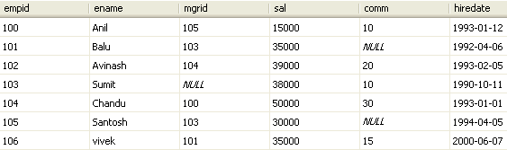
Sol:
Select a.empid,a.ename,a.mgrid,b.ename mgrName
From emp a inner join emp b
On a.mgrid=b.empid

Output:

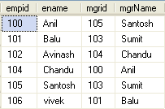

Internal Execution Process:
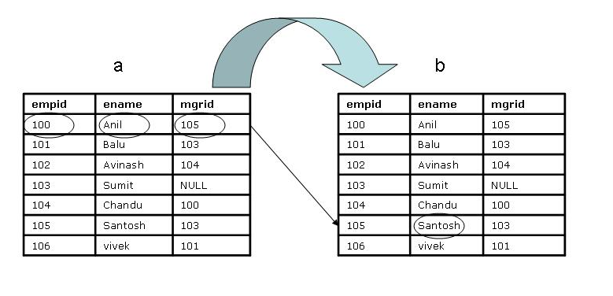
Joining more than two tables:
It is also possible to join more than two tables. In this case each table must have a relation with other table.
Syn:
Select <column list>
FROM <table1> INNER JOIN <table2> ON <criteria>
INNER JOIN <table3> ON <criteria>
INNER JOIN <table4> ON <criteria>
…………………………
………………………..

Ex: Get the full details of the orders made by the customers.
select cu.customerid,companyname,o.orderid,orderdate,
od.productid,productname,od.unitprice,quantity
from customers cu inner join orders o
on cu.customerid=o.customerid
inner join [order details] od
on o.orderid=od.orderid
inner join products p
on od.productid=p.productid

SUBQUERIES

A SubQuery is a SELECT statement containing another SELECT statement. In these SubQueries, at first, the inner query will be executed and based on the result next higher query will be executed. Whenever, it happened to compare a column data with the output of another select statement then we use sub queries.

Types Of SubQueries:

Based on the way the Select statements are provided and the way they will execute, SQL Server provides the following types of subqueries.

- Simple SubQuery
- Nested SubQuery
- Multiple SubQuery
- Correlated SubQuery

Simple SubQuery:

It is a select statement containing another select statement. At first inner query will be executed and based on the result next higher query will be executed.
Ex: Get the Second maximum salary from the following EMP table.
Sol:
SELECT max(Sal) FROM EMP
WHER sal<(SELECT max(Sal) FROM EMP)

Output: 39000

Neseted SubQueries:
A Nested SubQuery is a select statement, containing another select statement, which contains another select statement and so on. Such type of nesting nature of select statements is called as a nested subquery. In these subqueries, at first, the innermost query will be executed and based on the result next higher query will be executed and so on. A maximum of 32 select statements can be combined in these nested subqueries.
Ex: Get the Third maximum salary from the emp table

Sol: SELECT max(sal) FROM EMP
WHERE sal<(SELECT max(sal) FROM EMP
WHERE sal<(SELECT max(sal) FROM EMP))

Output: 38000
Multiple SubQueries:
It is select statement containing different select statements at different places.
Ex: List out the employees who are having salary less than the maximum salary and also having hiredate greater than the hiredate of an employee who is having the maximum salary.

Sol:
SELECT empid,ename,sal,hiredate FROM EMP
WHERE sal<(SELECT max(sal) FROM EMP) AND
hiredate>(SELECT hiredate FROM EMP
WHERE sal=(SELECT max(Sal) FROM EMP))

Output:

Empid | Ename | Sal | Hiredate
100 | Anil | 15000 | 1993-01-12
102 | Avinash | 39000 | 1993-02-05
105 | Santosh | 30000 | 1994-04-05
106 | vivek | 35000 | 2000-06-07

Correlated SubQueries:
In a normal subquery, at first, the inner query will be executed and only once. Based on the result next higher query will be executed.
Whereas in a correlated subquery, the inner query will be executed for each record of the parent statement table. The internal execution process of this subquery will be as follows:
- A record value from the parent table will be passed to the inner query.
- The inner query execution will be done based on that value.
- The result of the inner query will be sent back to the parent statement.
- The parent statement finishes the processing for that record.
The above 4 steps will be executed for each record of the parent table.

Examples:
- Get the nth maximum salary from the emp table.
Sol:
SELECT a.empid,a.ename,a.sal FROM EMP a
WHERE 2=(SELECT count(distinct(b.sal)) FROM EMP b
WHERE a.sal<b.sal)

Note: The above query is to calculate 3rd maximum salary. To calculate nth maximum salary specify the number “n-1” in place of “2”.
- Get the Top 3 maximum salaries from emp table.
Sol:
SELECT a.empid,a.ename,a.sal FROM EMP a
WHERE 3>(SELECT count(distinct(b.sal)) FROM EMP b
WHERE a.sal<b.sal)Order by a.sal desc

Output:
Empid | Ename | Sal
104 | Chandu | 50000
102 | Avinash | 39000
103 | Sumit | 38000

- Get the details of employees who are not the managers
Sol:
SELECT a.empid,a.ename FROM EMP a
Where 0=(SELECT count(*) FROM EMP b WHERE a.empid=b.mgrid)

Output:
Empid | Ename
102 | Avinash
106 | vivek

- Get the details of employees who are the managers for more than one employee
Sol:
SELECT a.empid,a.ename FROM EMP a
Where 1<(SELECT count(*) FROM EMP b WHERE a.empid=b.mgrid)

Output:
Empid | Ename
103 | Sumit

More Examples:

SubQueries With IN:
A subquery introduced with IN returns zero or more values. Consider the following example where all author ID’S, from the TITLEAUTHOR table, are displayed whose books are sold:
SELECT au_id
FROM titleauthor
WHERE title_id IN (SELECT title_id FROM sales)

SQL Server returns a list of all title IDs to the main query then lists all the authors, whose books are sold, in the result set.
Consider the following example where the server returns a list of publisher IDs to the main query, and then determines whether each publisher’s pub_id is in that list:
SELECT publisher=pub_name
FROM publishers
WHERE pub_id IN ( SELECT pub_id FROM titles WHERE type=’business’)

The inner query is evaluated first and then the result set is sent to the outer query.

Consider another subquery with the IN clause:
SELECT type=type, Average=AVG(ytd_sales)
FROM titles
WHERE type IN (SELECT type FROM titles
WHERE title=” the busy executive’s database guide” or title=’Is Anger the Enemy?’) GROUUP BY type

The inner query is evaluated first and then the result set is sent to the outer query.
The NOT IN clause is used in the same way as the IN clause. Consider the following example.

SELECT pub_id, pub_name
FROM publishers
WHERE pub_id NOT IN (SELECT pub_id FROM titles
WHERE type=’mod_cook’)

Sub Queries with EXISTS:
The subquery, when used with the EXISTS clause, always returns data in terms of TRUE OR FALSE and passes the status to the outer query to produce the results set. The subquery returns a TRUE value if the result set contains any rows.
The query introduced with the EXISTS keyword differs from other queries. The EXISTS keyword is not preceded by any column name, constant or there expression and it contains an asterisk (*) in the SELECT list.
1. SELECT pub_name
FROM publishers
WHERE EXISTS (SELECT * FROM titles WHERE type=’business’)

2. SELECT pub_name
FROM publishers
WHERE EXISTS (SELECT * FROM publishers WHERE City=’Paris’)

Aggregate functions can also be used in subqueries. Consider the following example which displays the titles of all those books for which the advance is more than the average advance of business related books.
SELECT Title=title
FROM titles
WHERE advance>(SELECT AVG (advance) from titles
WHERE type=’business’)

Subquery Restrictions:
The restrictions imposed are:
- The column list of the select statement of a subquery introduced with the comparison operator can include only one column.
- The column used in the WHERE clause of the outer query should be compatible with the column used in the select list of the inner query.
- The DISTINCT keyword cannot be used with the subqueries that include the GROUP BY clause.
- The ORDER BY clause, GROUP BY clause and INTO keyword cannot be used in a subquery, because a subquery cannot manipulate its result internally.
- Do not specify more than one column name in the subquery introduced with the EXISTS keyword.
- A view created with a subquery cannot be updated.

BUILT IN FUNCTIONS

SQL Server provides a lot of functions, which can be used as calculated fields as part of column lists in a SELECT statement. Such functions are called as Built-in Functions.

Types of Built-in Functions:
Based on the type of data we are using inside the functions, built-in functions are categorized into the following ways.
- Aggregate Functions
- Numeric Functions
- Date and Time Functions
- String Functions

Aggregate Functions:
Aggregate functions are used to produce summary data using tables.

Function | Parameters | Description
AVG | (ALL/DISTINCT] expression | Returns the average of values specified in the expression, either all records or distinct records
SUM | (ALL/DISTINCT] expression) | Returns the sum of values specified in the expression, either all records or distinct records.
MIN | (expression) | Returns the minimum of a value specified in the expression.
MAX | (expression) | Returns the maximum of a value specified in the expression.
COUNT | (ALL| DISTINCT expression) | Returns the number of unique or all records specified in expression.

Examples of Aggregate functions

SELECT ‘Average Price”=AVG(price) FROM titles | Returns the average value of all the price values in the titles table with user-defined heading.
SELECT ‘Sum’=SUM(DISTINCT advance) FROM titles | Returns the sum value of all-the unique advance values in the titles table with user-defined heading.
SELECT ‘Minimum Ytd Sales’=MIN(ytd_sales) FROM titles | Returns the minimum value of ytd_sales value in the titles table with user-defined heading.
SELECT ‘Maximum Ytd Sales’=MAX(ytd_sales) FROM titles | Returns the maximum value of ytd_sales in the titles table with user-defined heading.
SELECT ‘Unique Price’= COUNT(DISTINCT price) FROM titles | Returns the number of unique price values in the titles table with user-defined heading.
SELECT ‘Price=COUNT(price) FROM titles | Returns the number of total number of price values in the titles with user-defined heading.

NUMERIC FUNCTIONS:

- SQRT: Gets the square root of a number
EX: Select SQRT(25) --o/p: 5

- SQUARE: Gets the square of a number
Ex: select SQUARE(4) --o/p: 16

- POWER: Gets the power a number
Ex: select POWER(2,3) --o/p: 8

- ROUND: Used to round a floating point number to the required no.of decimal places
Ex: 1. Select ROUND(12.347,2) --o/p: 12.35
2. select ROUND(12.343,2) --o/p: 12.34

- CEILING:Returns the nearest higher integer value for the given number
Ex: select CEILING(12.345) --o/p:13

- FLOOR:Returns the nearest smaller integer value for the given number
Ex: select FLOOR(12.345) --o/p:12

Date and Time Functions:

- GETDATE: Returns system date and time
Ex: select GETDATE() --o/p: 2010-06-10 22:44:18.187

- DATEPART: Returns the part of given date or time.
Syn: DATEPART(Format,Date)

Format | Output | Format | Output
dd | Days | mi | Minutes
mm | Months | ss | Seconds
yy | Years | ms | Milliseconds
hh | Hours | dw | Day of Week
mi | Minutes | dy | Day of Year
ss | Seconds

ex: 1. select datepart(dd,getdate()) --10
2. select datepart(hh,getdate()) --22

- DATENAME: It Returns the name of the corresponding datepart. If the specified datepart is not having a name, this function will return that value directly.

Syn: DATENAME(datepart,date)

Ex:
1. select datename(dw,getdate()) --Friday
2. select datename(mm,getdate()) --June
3. select datename(dd,getdate()) --10
4. select datename(dw,'10/21/77') --Friday
5. calculate how many employees joined in each weekday from the emp table
select datename(dw,hiredate),count(*) from emp
group by datename(dw,hiredate)

- DATEADD: It is used to add a number to a part of a date. If we specify a negative value, the number will be subtracted from the given datepart.

Syn: DATEADD(datepart,n,date)

Ex:
- select dateadd(dd,3,getdate()) --2010-06-13

2. Getting the weekday name which was 10 days before
today's date
sol:-select datename(dw,dateadd(dd,-10,getdate()))
--o/p: Saturday

- DATEDIFF: Returns the difference between two given dates. The output will be the subtraction of date1 from date2. The difference can be in days or months or years etc., based on the interval specified.

Syn: DATEDIFF(interval, data1, date2)

Ex: Get the experience of each employee from the employee table.
ex: Get the experience of each employee from the
employee table.
SOL: SELECT empid,ename,datediff(yy,hiredate,getdate()) FROM EMP

f. CONVERT: SQL server handles certain datatype conversion automatically. If a character expression is compared with an int expression, SQL server makes the conversion automatically for the comparison(implicit conversion).

The CONVERT function is used to change data from one type to another when SQL server cannot implicitly perform a conversion. Using the CONVERT function, data can be modified in variety of styles.

The syntax is:
CONVERT(datatype[(length), expression[,style])

Ex:
- SELECT Ytd_Sales=CONVERT(char(10),ytd_sales)
FROM titles.

- SELECT CONVERT(char,getdate(),101) --06/10/2010

STRING FUNCTIONS:
FUNCTION | DESCRIPTION
CHARINDEX(‘pattern’, expression) | Returns the starting position of the specified pattern.
LOWER (character_expression) | Converts two string and evaluates the similarity between them on a scale of 1 to 4.
LTRIM(character_expression) | Returns the data without leading brackets
REPLICATE(char_expression, integer_expression | Repeats a character expression a specified number of times.
REVERSE(character_expression) | Returns the reverse of character expression.
RIGHT(character_expression, integer_expression) | Returns the part of the character string from the right.
RTRIM(character_expression) | Returns the data without tailing blanks.
SPACE(numeric_expression) | Returns a string of repeated spaces. The number of spaces is equal to the integer expression.
UPPER(character_expression) | Converts the character expression into upper case.

OPERATORS

An operator is a symbol specifying an action that is performed on one or more expressions. SQL Server provides few methods of searching rows in a table. These methods can be broadly categorized into the following categories.

- Arithmetic Operators like +, -, /, * ,%
- Comparison operators like =, >, <, >=, <=, !=, !< and !>
- Range operators like BETWEEN and NOT BETWEEN.
- List operators line IN and NOT IN.
- String operators like LIKE and NOT LIKE.
- Unknown values like IS NULL and NOT NULL.
- Logical operators like AND , OR and NOT.

Arithmetic operators:

The arithmetic operators supported by SQL server are:

- + for addition
- - for subtraction
- / for division
- * for multiplication
- % for modulo

The modulo arithmetic operator is used to obtain the remainder of two divisible numeric integer values. It cannot be used with money data type columns.

All the arithmetic operators can be used in the SELECT list with the column names and numeric constants in a combination.
Example:
SELECT title_id, price, price+5, ytd_sales*5 FROM titles.
When any arithmetic operation is performed on a NULL value, the result is always NULL because NULL values have no explicitly assigned values. Arithmetic operations can be performed on more than one column at a time. Consider the following query code:
SELECT Title_Id=title_id, sValue=ytd_sales*price FROM tiles

The above query computes the product of ytd_sales and price from the titles table and displays the output with the user-defined headings.

Some rules regarding the usage of arithmetic operators are:
- Arithmetic operations can be performed on numeric columns or numeric constants.
- The modulo (%) operator cannot be used with columns of money, smallmoney, float or real datatypes.

Comparison Operators:
The command syntax is:
SELECT column_list FROM table_name WHERE expression1 comparison_operator expression2

Valid Comparison operators
Operator | Description
= | Equal to
> | Greater than
< | Less than
>= | Greater than or Equal to
<= | Less than or Equal to
<>, != | Not Equal to
!> | Not Greater than
!< | Not Less than
() | Controls Precedence

Examples:
SELECT title FROM titles WHERE type=’business’
SELECT stor_id, ord_num, title_id FROM sales WHERE qty>20
SELECT type, title_id, price FROM titles
WHERE price * ytd_sales<advance.

Range Operator:

The range operator is used to retrieve data that can be extracted in ranges. The range operations are:
- BETWEEN
- NOT BETWEEN
The syntax is:
SELECT column_list FROM table_name WHERE expression1 range_operator expression2 AND expression2

Examples:

- SELECT title from titles
WHERE advance BETWEEN 2000 AND 5000
2. SELECT title FROM titles
WHERE advance NOT BETWEEN 4000 AND 5000

List Operator
The syntax is:
SELECT column_list FROM table_name WHERE expression list_operator(‘value_list’)

Examples:

1. SELECT pub_name, city, state FROM publishers
WHERE state IN (‘MA’, ‘DC’)

2. SELECT pub_name, city, state FROM publishers
WHERE state NOT IN (‘MA’, ‘DC’)

LIKE Operator:

SQL Server provides a pattern-matching method for string expressions using the LIKE keyword with the wildcard characters. The LIKE keyword is used to select those rows that match the specified portion of character string. The LIKE keyword allows wildcard characters that can be used as a part of an expression.

Wild card | Description
% | Represents any string of zero or more characters(s)
- | Represents a single character
[] | Represents any single character within the specified range.
[^] | Represents any single character not within the specified range.

Examples of the LIKE operator with wildcards.

Example | Description
SELECT title FROM titles WHERE type LIKE ‘bus%’ | Returns all titles from titles table where first three characters of the column type are ‘bus’
SELECT * FROM publishers WHERE country LIKE ‘US_’ | Returns all rows from publishers table where country name is three characters long and starts with US where the third character can be anything.
SELECT title_id, price FROM titles WHERE title_id LIKE ‘P[SC]]%’ | Returns all columns from the titles table where title_id starts with the character P and contains S or C in the second position followed by any number of characters.
SELECT title_id, price FROM titles WHERE title_id, LIKE ‘P[^C]%’ | Returns all title_id and price from the titles table where title_id starts with P and does not contain and S as the second character and the third position onwards can contain any characters.

Unknown Values:
Unknown values refer to the data entered in the form of the NULL keyword. In SQL server terms, NULL is an unknown value or the value for which data is not available. The rows containing the NULL values can be retrieved by using the IS NULL keyword in the WHERE clause.

The Syntax is:
SELECT column_list FROM table_name
WHERE column_name unknown_value_operator.

SELECT title, ytd_sales FROM titles WHERE ytd_sales IS NULL
Logical Operator
- OR – Returns the result when any of the specified search conditions is true.
- AND – returns the result when all of the specified search conditions are true.
- NOT – Bnegates the expression that follows it.

SELECT column_list FROM table_name
WHERE conditional_expression{AND\OR}[NOT] conditional_expression.

Examples of Logical operators

Example | Description
SELECT * FROM publishers WHERE city=’Boston’ OR city=’Paris’ | Returns all the rows specific to the conditions, even if any one of the conditions is true.
SELECT publishers WHERE city=’Boston’ AND city=’MA’ | Returns all the rows specific to the conditions, when both the conditions are true.
SELECT * FROM publishers WHERE city=’Boston’ OR NOT city=’Paris’ | Returns all the rows specific to the conditions, except the rows specified with the condition after NOT operator.
VIEWS

A view is a virtual table, which gives access to a subset of columns from one or more tables. Hence, a view is an object that derives its data from one or more tables. These tables are referred to as the base tables or the underlying tables.
Views ensure security of data by restricting access to the following data:
- Specific rows of the table
- Specific columns of the table.
- Rows fetched by using joins.
- Statistical summary of data in a given table.
- Subsets of another view or a subset of views and tables
Common examples of views include:
- A subset of rows or columns of a base table.
- A union of two or more tables
- A join of two or more tables
- A statistical summary of a base tables
- A subset of another view, or some combination of views and base tables.

Creating Views:
Using the CREATE VIEW statement we can create a view.

The syntax of the CREATE VIEW statement is:

CREATE VIEW view_name
[(column_name [,column_name]….)]
[WITH ENCRYPTION][WITH SCHEMABINDING]
AS select_statement[WITH CHECK OPTION]

The restrictions imposed on views are as follows:
- A view can be created only in the current database.
- A view can be created only if there is the SELECT permission on its base table.
- The SELECT INTO statement cannot be used in a view declaration statement.
- A view cannot derive its data from temporary tables.

Example:
USE NORTHWIND
GO

CREATE VIEW custview
AS
SELECT customerid, companyname, phone FROM customers
GO

The above statements create a view named custview, which contains the custoemerid, companyname and the phone columns of the customer table. The following statement can be used to execute a view:
SELECT * from custview

Getting View Information
SQL Server stores information in a view in the following system tables.
- Sysobjects-stores the name of the view
- Syscolumns-stores the names of the columns defined in the view.
- Sysdepends-stores information on the view dependencies
- Syscomments-stores the text of the view definition

Altering a view:

A view can be modified without dropping it. It ensures that the permissions on the view are not lost. A view can be altered without affecting its dependent objects, such as, triggers and stores procedures.

A view can be modified using the ALTER VIEW statement.

The syntax of ALTER VIEW statement is:

ALTER VIEW view_name([column_name])

[WITH ENCRYPTION]

AS

Select_statement

[WITH CHECK OPTION]

Example:

ALTER VIEW custview

AS

SELECT customerid, companyname, phone, fax
From customers

The statement generates the results:

SELECT * FROM custview

Dropping a View:

A view can be dropped from a database using the DROP VIEW statement. When a view is dropped, it has no effect on the underlying table(s). Dropping a view removes its definition and all permissions assigned to it. Further more if users query any views that refer to a dropped view, they receive an error message. However, dropping a table that refers to a view does not drop the view automatically. You must drop it explicitly.
The syntax of DROP VIEW statement is:
DROP VIEW view_name
Where view_name is the name of the view to be dropped.

It is possible to drop multiple views with a single DROP VIEW. A comma in the DROP statement separates each view that needs to be dropped.

Renaming a View:
A view can be renamed without dropping it. This also ensures that the permissions on the view are not lost.
The guidelines to be followed for renaming a view as follows.
- The view must be in the current database.
- The new name for the view must follow the rules for renaming identifiers.
- Only the owner of the view and the database in which view is created can rename a view.
A view can be renamed by using the sp_rename system stored procedure.
The syntax of sp_rename is
Sp_rename old_viewname ,new_viewname

Example:
sp_rename custview,customerView

Note: All view are not modifiable. If the modification to the view is affecting multiple base tables, then we can’t perform such modifications. If the modification to the view is affecting a single base table, then we can perform that modification

With Encryption:
Without this option in the view, the view design can be viewed by anybody who have access on the view. In order to stop this we can encrypt the view with this option. Once we encrypted the view we can’t decrypt again. So, it is important to maintain a copy of the script.
Ex:
Create view vSample
WITH ENCRYPTION
AS
Select sid,sname,student.cid,cname
From student inner join class
On student.cid=class.cid
With SchemaBinding: (Materialized Views)

A view with an index is called a Materialized view. In order to create an index on the view we must follow these points:
- View must be created using ‘WITH SCHEMABINDING’
- At first we must have a ‘UNIQUE CLUSTERED’ index on the view
- After that only we can create a ‘NONCLUSTERED’ index.

- Create view vSample
WITH SCHEMABINDING
AS
Select sid,sname,student.cid,cname
From student inner join class
On student.cid=class.cid
- CREATE UNIUQE NONCLUSTERED INDEX isid on vsample(sid)
- CREATE INDEX iCid on vsample(cid)

With CheckOption:

In general even the modification on the view affects the view criteria, we can perform that modification. To stop this we can use ‘WITH CHECK OPTION’.
- Create view vEmp
As
Select empid,ename,sal from emp
Where sal>35000
- Update vemp set sal=25000 where empid=101
--no error, even empid 101 contains salary 35000.

- alter view vemp
as
Select empid,ename,sal from emp
Where sal>35000 WITH CHECK OPTION
- UPDATE vemp set sal=25000 where empid=104;
--error, since this employee salary is 39000. If we modify this, it will violate the view condition

SYNONYMS

A synonym is a database object that serves the following purposes:
- It provides an alternative name for another database object, referred to as the base object, that can exist on a local or remote server.
- It provides a layer of abstraction that protects a client application from changes made to the name or location of the base object.

Synonyms can be created for the following types of objects:

Assembly (CLR) Stored Procedure | Assembly (CLR) Table-valued Function
Assembly (CLR) Scalar Function | Assembly Aggregate (CLR) Aggregate Functions
Replication-filter-procedure | Extended Stored Procedure
SQL Scalar Function | SQL Table-valued Function
SQL Inline-table-valued Function | SQL Stored Procedure
View | Table¹ (User-defined)

Creating a Synonym:
Syn:
CREATE SYNONYM [ schema_name_1. ] synonym_name FOR < object >
< object > :: =
{
[ server_name.[ database_name ] . [ schema_name_2 ].| database_name . [ schema_name_2 ].| schema_name_2. ] object_name
}

Creating a synonym for a local object:
The following example first creates a synonym for the base object, Product in the AdventureWorks database, and then queries the synonym.
USE tempdb;
GO
-- Create a synonym for the Product table in AdventureWorks.
CREATE SYNONYM MyProduct
FOR AdventureWorks.Production.Product;
GO

-- Query the Product table by using the synonym.
USE tempdb;
GO
SELECT ProductID, Name
FROM MyProduct
WHERE ProductID < 5;
NORMALIZATION

Normalization is a technique for producing a set of relations with desirable properties, given the data requirements of an enterprise.

The process of normalization is a formal method that identifies relations based on their primary or candidate / foreign keys and the functional dependencies among their attributes.

The Process of Normalization:
- Normalization is often executed as a series of steps. Each step corresponds to a specific normal form that has known properties.

- As normalization proceeds, the relations become progressively more restricted in format, and also less vulnerable to update anomalies.

- For the relational data model, it is important to recognize that it is only first normal form (1NF) that is critical in creating relations. All the subsequent normal forms are optional.
Basically 6 normal forms are avilable. They are:
- 1NF
- 2NF
- 3NF
- BCNF(Boyce-codd NF)
- 4NF
- 5NF
Mostly the realtime database designs ends with 3NF. It means, if we satisfy the rules of 3NF.

Case Study:
There is a consulting company which acts a consultant for property owners and clients who require property for rent.

Unnormalized form (UNF)
A table that contains one or more repeating groups

ClinetRental

Client  No | cName | Property  No | pAddress | Rent  Start | Rent  Finish | rent | Owner  No | oName
CR76 | John  kay | PG4  PG16 | 6 lawrence  St,Glasgow  5 Novar Dr,  Glasgow | 1-Jul-00  1-Sep-02 | 31-Aug-01  1-Sep-02 | 350  450 | CO40  CO93 | Tina Murphy  Tony Shaw
CR56 | Aline  Stewart | PG4  PG36  PG16 | 6 lawrence  St,Glasgow  2 Manor Rd,  Glasgow  5 Novar Dr,  Glasgow | 1-Sep-99  10-Oct-00  1-Nov-02 | 10-Jun-00  1-Dec-01  1-Aug-03 | 350  370  450 | CO40  CO93  CO93 | Tina Murphy  Tony Shaw  Tony Shaw

Definition of 1NF
First Normal Form is a relation in which the intersection of each row and column contains one and only one value.
There are two approaches to removing repeating groups from unnormalized tables:

1.Removes the repeating groups by entering appropriate data in the empty columns of rows containing the repeating data.
2. Removes the repeating group by placing the repeating data, along with a copy of the original key attribute(s), in a separate relation. A primary key is identified for the new relation

1NF ClientRental relation with the first approach

With the first approach, we remove the repeating group (property rented details) by entering the appropriate client data into each row.

The ClientRental relation is defined as follows,

ClientRental ( clientNo, propertyNo, cName, pAddress, rentStart, rentFinish, rent, ownerNo, oName)

Client  No | Propery  No | CName | PAddress | Rent  Start | Rent  Finish | Rent | Owner  No | oName
CR76 | PG4 | John  Kay | 6 Lawrence,  Glasgow | 1-Jul-00 | 31-Aug-01 | 350 | C040 | Tina  Murphy
CR76 | PG16 | John  Kay | 5  NovarDr,  Glasgow | 1-Sep-02 | 1-Sep-02 | 450 | C093 | Tony  Shaw
CR56 | PG4 | Aline  Stewart | 6 Lawrence,  Glasgow | 1-Sep-99 | 10-Jun-00 | 350 | C040 | Tina  Murphy
CR56 | PG36 | Aline  Stewart | 2 ManorRd,  Glasgow | 10-Oct-00 | 1-Dec-01 | 370 | C093 | Tony  Shaw
CR56 | PG16 | Aline  Stewart | 5  NovarDr,  Glasgow | 1-Nov-02 | 1-Aug-03 | 450 | C093 | Tony  Shaw

1NF ClientRental relation with the second approach

With the second approach, we remove the repeating group (property rented details) by placing the repeating data along with a copy of the original key attribute (clientNo) in a separte relation.

Client (clientNo, cName)
PropertyRentalOwner (clientNo, propertyNo, pAddress, rentStart, rentFinish, rent, ownerNo, oName)

Client

ClientNo | cName
CR76 | PG4
CR76 | PG16

PropertyRentalOwner
Client  No | Propery  No | PAddress | Rent  Start | Rent  Finish | Rent | Owner  No | oName
CR76 | PG4 | 6 Lawrence,  Glasgow | 1-Jul-00 | 31-Aug-01 | 350 | C040 | Tina  Murphy
CR76 | PG16 | 5  NovarDr,  Glasgow | 1-Sep-02 | 1-Sep-02 | 450 | C093 | Tony  Shaw
CR56 | PG4 | 6 Lawrence,  Glasgow | 1-Sep-99 | 10-Jun-00 | 350 | C040 | Tina  Murphy
CR56 | PG36 | 2 ManorRd,  Glasgow | 10-Oct-00 | 1-Dec-01 | 370 | C093 | Tony  Shaw
CR56 | PG16 | 5  NovarDr,  Glasgow | 1-Nov-02 | 1-Aug-03 | 450 | C093 | Tony  Shaw

Second Normal Form (2NF)

Second normal form (2NF) is a relation that is in first normal form and every non-primary-key attribute is fully functionally dependent on the primary key.

The normalization of 1NF relations to 2NF involves the removal of partial dependencies. If a partial dependency exists, we remove the function dependent attributes from the relation by placing them in a new relation along with a copy of their determinant.

The ClientRental relation has the following functional dependencies:

fd1 clientNo, propertyNo & rentStart, rentFinish (Primary Key)
fd2 clientNo & cName (Partial dependency)
fd3 propertyNo & pAddress, rent, ownerNo, oName (Partial dependency)
fd4 ownerNo & oName (Transitive Dependency)
fd5 clientNo, rentStart à propertyNo, pAddress,
rentFinish, rent, ownerNo, oName (Candidate key)
fd6 propertyNo, rentStart & clientNo, cName, rentFinish (Candidate key)

2NF ClientRental relation

After removing the partial dependencies, the creation of the three new relations called Client, Rental, and PropertyOwner

Client (clientNo, cName)
Rental (clientNo, propertyNo, rentStart, rentFinish)
PropertyOwner (propertyNo, pAddress, rent, ownerNo, oName)

Client
ClientNo | cName
CR76 | PG4
CR76 | PG16

Rental
ClientNo | Propery No | RentStart | RentFinish
CR76 | PG4 | 1-Jul-00 | 31-Aug-01
CR76 | PG16 | 1-Sep-02 | 1-Sep-02
CR56 | PG4 | 1-Sep-99 | 10-Jun-00
CR56 | PG36 | 10-Oct-00 | 1-Dec-01
CR56 | PG16 | 1-Nov-02 | 1-Aug-03

Property Owner
Propery No | PAddress | Rent | OwnerNo | oName
PG4 | 6 Lawrence,  Glasgow | 350 | C040 | Tina  Murphy
PG16 | 5 NovarDr,  Glasgow | 450 | C093 | Tony  Shaw
PG4 | 6 Lawrence,  Glasgow | 350 | C040 | Tina  Murphy
PG36 | 2 ManorRd,  Glasgow | 370 | C093 | Tony  Shaw
PG16 | 5 NovarDr,  Glasgow | 450 | C093 | Tony  Shaw

Third Normal Form (3NF)

A Relation that is in first and second noraml form, and in which no non-primary key attribute is Transitively dependent on the primary key

Transitive dependency
A condition where A, B, and C are attributes of a relation such that if A & B and B & C, then C is transitively dependent on A via B
(provided that A is not functionally dependent on B or C).

The normalization of 2NF relations to 3NF involves the removal of transitive dependencies by placing the attribute(s) in a new relation along with a copy of the determinant.

The functional dependencies for the Client, Rental and PropertyOwner relations are as follows:

Client
fd2 clientNo cName (Primary Key)

Rental
fd1 clientNo, propertyNo & rentStart, rentFinish (Primary Key)
fd5 clientNo, rentStart & propertyNo, rentFinish (Candidate key)
fd6 propertyNo, rentStart & clientNo, rentFinish (Candidate key)

PropertyOwner
fd3 propertyNo & pAddress, rent, ownerNo, oName (Primary Key)
fd4 ownerNo & oName (Transitive Dependency)

3NF ClientRental relation

The resulting 3NF relations have the forms:

Client (clientNo, cName)
Rental (clientNo, propertyNo, rentStart, rentFinish)
PropertyOwner (propertyNo, pAddress, rent, ownerNo)
Owner (ownerNo, oName)

Client Owner
ClientNo | cName
CR76 | PG4
CR76 | PG16
OwnerNo | OName
C040 | Tina Murphy
C093 | Tony Shaw

Rental
ClientNo | Propery  No | RentStart | RentFinish
CR76 | PG4 | 1-Jul-00 | 31-Aug-01
CR76 | PG16 | 1-Sep-02 | 1-Sep-02
CR56 | PG4 | 1-Sep-99 | 10-Jun-00
CR56 | PG36 | 10-Oct-00 | 1-Dec-01
CR56 | PG16 | 1-Nov-02 | 1-Aug-03

Property Owner
Propery No | PAddress | Rent | OwnerNo | oName
PG4 | 6 Lawrence,  Glasgow | 350 | C040 | Tina  Murphy
PG16 | 5 NovarDr,  Glasgow | 450 | C093 | Tony  Shaw
PG4 | 6 Lawrence,  Glasgow | 350 | C040 | Tina  Murphy
PG36 | 2 ManorRd,  Glasgow | 370 | C093 | Tony  Shaw
PG16 | 5 NovarDr,  Glasgow | 450 | C093 | Tony  Shaw

BACKING UP AND RESTORING DATABASES

The backup and restore component of Microsoft® SQL Server™ 2000 provides an important safeguard for protecting critical data stored in SQL Server databases.
With proper planning, you can recover from many failures, including:
- Media failure.
- User errors.
- Permanent loss of a server.
Additionally, backing up and restoring databases is useful for other purposes, such as copying a database from one server to another. By backing up a database from one computer and restoring the database to another, a copy of a database can be made quickly and easily.
Using the Enterprise Manager to take backup of database:
- Open the Management Studio tool and expand “Databases” item.
- Right click on the corresponding database and choose “Tasks -> Backup…”
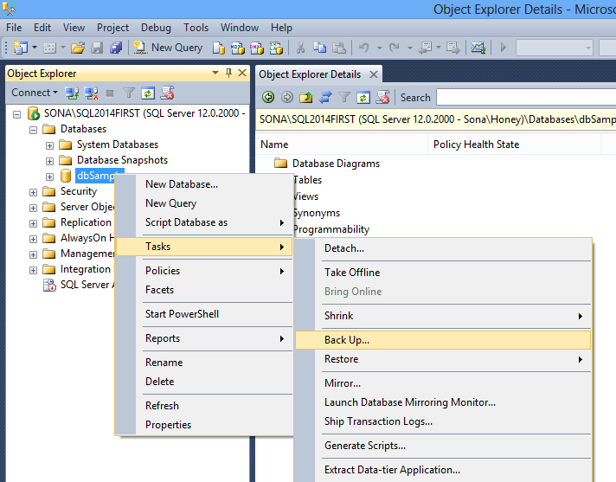
- In the window displayed click on ADD button and choose the location where the backup to be stored along with name.

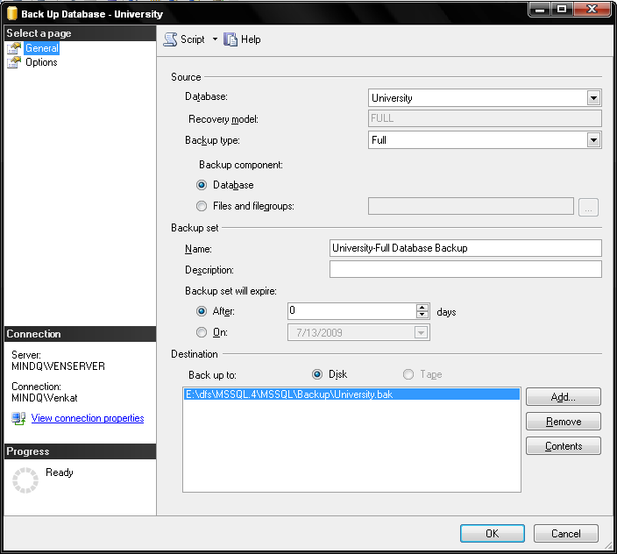

- Click on “Options” tab and choose “Overwrite existing backup sets” option

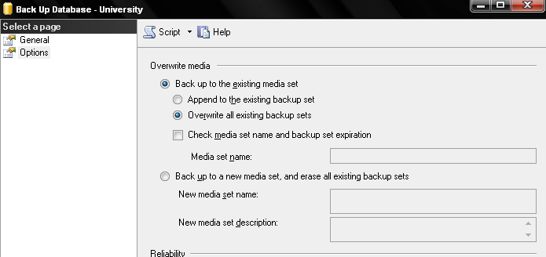
- Click “OK”
Recovering Database :

- Open Management Studio Tool
- Right click on the “Databases” item and select “Restore Database…” option.

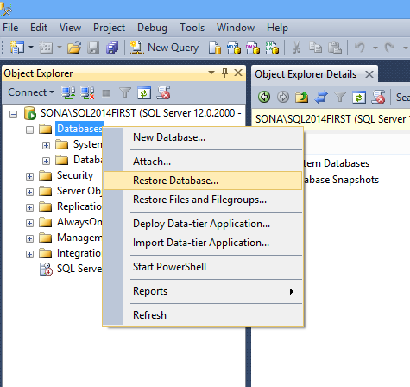

- In the window displayed choose “Device” option button and Click (browse) button
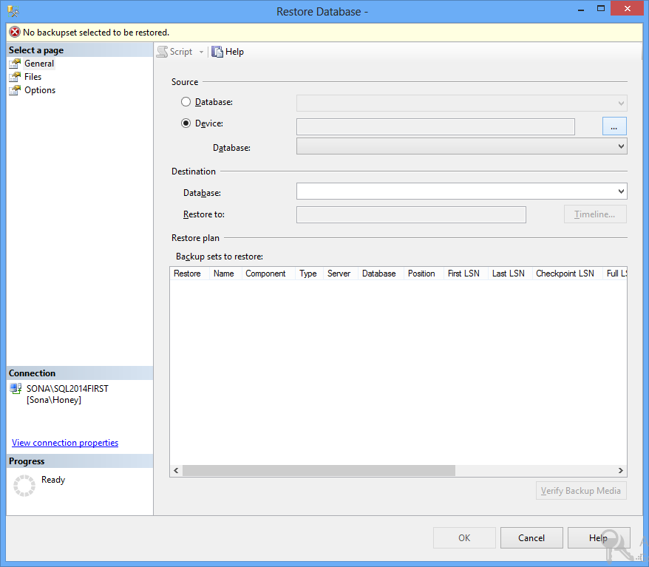

- Choose the file from the “Locate Backup file” window.
- Select “ok”
- Make a check mark under “Restore” item for the corresponding backup database file.
- Click on “Options” tab and choose “Overwrite Existing Database” option
- Click “OK” button.
Note: If any error occurred regarding path, change the path under “Restore As” to new path.

FREQUENTLY ASKED QUESTIONS

- What are the new data types in SQL Server?
- How to get the version of SQL Server?
- What are system Databases?
- What happens if we delete any one of either Master or Model databases?
- What are data files?
- What is the Maximum number of databases that can be created for an instance of SQL Server?
- What is identity property?
- How to insert explicit values into identity column?
- What is the maximum size of data that can be entered in a single row of a table?
- How to get the table names in the database?
- How to insert multiple rows using insert statement?
- Difference between DELETE and TRUNCATE?
- Difference between WHERE and HAVING clauses?
- What are the types of Integrity Constraints?
- Difference between UNIQUE and PRIMARY KEY?
- What is composite primary key?
- How many columns can be given in a composite primary key?
- What is ON DELETE CASCADE?
- How many references can be given to a table?
- What are Joins? Types of Joins?
- What is a correlated sub query?
- What is the difference between IN and ANY Operators?
- What is a View?
- What is an Index? What are the types of indexes?
- How many Clustered Indexes can be created on a table?
- How may NonClustered Indexes be able to be created on a table?
- What is Normalization?
- What are the Normal Forms?
- Write a query to get n^{th} maximum salary?
- How to delete duplicate rows from a table?
- What are the authentications available in sql sever?
- What are the authentication modes available?

Solutions

- SQL Server 2000 introduces three new data types. bigint is an 8-byte integer type. sql_variant is a type that allows the storage of data values of different data types. table is a type that allows applications to store results temporarily for later use. It is supported for variables, and as the return type for user-defined functions.

- The following 3 commands can be used to get the version of SQL Server
  - Select @@Version
  - EXEC sp_msgetversion
  - Exec xp_msver

- With the installation of SQL Server 4 databases will be created automatically, called as System Databases. They are:
  - MASTER
  - MODEL
  - MSDB
  - TEMPDB

Master: The master database records all of the system level information for a SQL Server system. It records all login accounts and all system configuration settings. Master is the database that records the existence of all other databases, including the location of the database files. Master records the initialization information for SQL Server.

Model: The model database is used as the template for all databases created on a system. When a CREATE DATABASE statement is issued, the first part of the database is created by copying in the contents of the model database, then the remainder of the new database is filled with empty pages.
MSDB: The msdb database is used by SQL Server Agent for scheduling alerts and jobs, and recording operators.
TempDB: While performing some complex operations, sometimes, we may need to store the results temporarily somewhere. To do this task we use temporary tables. Whatever database we are using, if we create a temporary table that will be created in tempdb database only. tempdb is re-created every time SQL Server is started so the system starts with a clean copy of the database.
- SQL Server won’t work properly if we delete any one of Master or Model databases.

- Microsoft® SQL Server maps a database over a set of operating-system files. There are the locations where the original database data will be stored. Data and log information are never mixed on the same file, and individual files are used only by one database.
SQL Server databases have three types of files:
- Primary data files
The primary data file is the starting point of the database and points to the other files in the database. Every database has one primary data file. The recommended file name extension for primary data files is .mdf.
- Secondary data files
Secondary data files comprise all of the data files other than the primary data file. Some databases may not have any secondary data files, while others have multiple secondary data files. The recommended file name extension for secondary data files is .ndf.
- Log files
Log files hold all of the log information used to recover the database. There must be at least one log file for each database, although there can be more than one. The recommended file name extension for log files is .ldf.

- 32,767

- Identity:
Auto number generated columns can be implemented using the IDENTITY property, which allows the application developer to specify both an identity number for the first row inserted into the table (Seed property) and an increment (Increment property) to be added to the seed to determine successive identity numbers. When inserting values into a table with an identifier column, Microsoft® SQL Server™ 2000 automatically generates the next identity value by adding the increment to the seed.

- In general we can’t enter values into an identity column directly. To do this we have to follow the two steps
  - Set the IDENTITY_INSERT to ON for that table
  - Specify the column list in the INSERT statement
EX: Suppose there is a table called STD with two columns SID and SNAME. SID is an identity column.
  - set IDENTITY_INSERT std ON
  - Insert into std(Sid,sname) values (5,’Anil’)

- 8060 bytes

- To get the name of all the tables in a database you can use one of the following 3 methods.
  - SELECT * FROM INFORMATION_SCHEMA.TABLES
WHERE TABLE_TYPE=’BASE TABLE’
- SELECT NAME FROM SYSOBJECTS WHERE TYPE=’U’
- EXEC SP_TABLES →returns all tables (system, user

  - SELECT * FROM INFORMATION_SCHEMA.TABLES
WHERE TABLE_TYPE=’BASE TABLE’
- SELECT NAME FROM SYSOBJECTS WHERE TYPE=’U’
- EXEC SP_TABLES →returns all tables (system, user

- sample table: create table tName(firstName varchar(20))
INSERT INTO TNAME
SELECT ‘RAJ’ UNION ALL
SELECT ‘GOPI’ UNION ALL
SELECT ‘VIVEK’

- Both TRUNCATE and DELETE commands are used to delete the data from the table. The difference between them is :
  - With TRUNCATE entire table data will be deleted. Whereas with DELETE command we can delete entire table data as well as certain row data, which is not possible with TRUNCATE.
  - Even though, we are deleting entire table data, the deletion will be done row by row. Where as, with TRUNCATE, the deletion will be done at once.
  - DELETE maintains log information about the deleted records. Where as, TRUNCATE does not maintain log details. Instead of this, it maintains deallocation of Data Pages.

- Both WHERE and HAVING clauses are used to provide a restriction to the result set. Only, those records, which satisfy the criteria, will be returned. The difference between them is:
  - With WHERE clause the condition can be provided based on any column of table. Whereas, by using HAVING clause, the condition can be specified either by using an Aggregate Function or a GROUP BY column.
  - Suppose, if the SELECT statement contains WHERE and GROUP BY clauses, the WHERE clause should precede GROUP BY clause. Whereas, if the SELECT statement contains GROUP BY and HAVING clauses, the HAVING clause should come after GROUP BY clause.

- Integrity Constraints are used to maintain Data Integrity in the database. It is a restriction that can be applied on a column or a table. 3 types of Integrity constraints are available
  - DOMAIN INTEGRITY: They can be applied on a column of a table. It ensures that a column should satisfy specified criteria. Ex: CHECK
  - ENTITY INTEGRITY: they can be provided on a column or on a table. It ensures that the column must have unique (non=duplicate) values.
Ex. UNIQUE, PRIMARY KEY
- REFERENCIAL INTEGRITY: Referential integrity preserves the defined relationships between tables when records are entered or deleted. In Microsoft® SQL Server™ 2000, referential integrity is based on relationships between foreign keys and primary keys or between foreign keys and unique keys (through FOREIGN KEY and CHECK constraints). Referential integrity ensures that key values are consistent across tables. Such consistency requires that there be no references to nonexistent values and that if a key value changes, all references to it change consistently throughout the database.
When you enforce referential integrity, SQL Server prevents users from:
- Adding records to a related table if there is no associated record in the primary table.
- Deleting records from a primary table if there are matching related records.
- The differences between UNIQUE and PRIMARY KEY are:
  - UNIQUE allows NULL values whereas, a PRIMARY KEY does not allow a NULL value.
  - A table can contain more than one UNIQUE constraint whereas, a table can have only one PRIMARY KEY.
  - An UNIQUE constraint on a column by default creates a NONCLUSTERED INDEX. Whereas, a PRIMARY KEY on a column by default creates a CLUSTERED INDEX

- In general a PRIMARY KEY can be given on a column by which we can able to identity different rows of the table. Suppose, it is not possible to identity different rows of the table based on a single column which can be done with combination of columns, then we will make that combination as the primary key which is called as COMPOSITE PRIMARY KEY.

- 16 columns.

- In general if the parent table record is having a reference In the child table, we can’t delete the record directly. With the use of “ON DELETE CASCADE”, when we delete the parent table record, that record and all its child references will be deleted at once.

- A table can have as many as 253 references.

- A JOIN is a select statement used to get the data distributed among different tables.
Types of Joins:
- Inner Join: Returns only the matching records between the two tables based on the criteria.
- Outer Join: Returns left alone records along with matching records.
  - Left Outer Join: Returns all the matching records between the two tables and all the left alone records from left table.
  - Right Outer Join: Returns all the matching records between the two tables and all the left alone records from Right table.
  - Full Outer Join: Returns all the matching records between the two tables and all the left alone data from left table as well as all the left alone data from the right table.
- Cross Join: A cross join that does not have a WHERE clause produces the Cartesian product of the tables involved in the join. The size of a Cartesian product result set is the number of rows in the first table multiplied by the number of rows in the second table. This is an example of a Transact-SQL cross join. Cross joins return all rows from the left table, each row from the left table is combined with all rows from the right table.
- Self Join: Joining a table to itself is called as self Join. In a self join we have to use two copies of the same table to join them. To distinguish the two copies, we use duplicate names to the tables called as ‘table aliases’.

- Correlated Sub Query: In a normal sub query, at first the inner query will be executed and based on the result the parent query will be executed. Both queries will execute only once.
Whereas, in a Correlated Sub Query, the inner query will execute for each and every row of the parent query. The internal process in the execution of a correlated sub query is as follows.
- The outer query passes the value of the first record into the inner query.
- The inner query then executes based on the values passed in. and it passes the resultant values back to the parent query.
- The parent query uses those values to finish the processing.
The above 3 steps should be performed for each row of the parent query.

- IN operator can be used to provide the list of values to checked, either by using explicit list of values and also with the resultant values of a SELECT statement, which is not possible with ANY operator, where we can use only the SELECT statement to specify the list of values.

- A view can be thought of as either a virtual table or a stored query. The data accessible through a view is not stored in the database as a distinct object. What is stored in the database is a SELECT statement. The result set of the SELECT statement forms the virtual table returned by the view. A user can use this virtual table by referencing the view name in Transact-SQL statements the same way a table is referenced. A view is used to do any or all of these functions:
- Restrict a user to specific rows in a table.
For example, allow an employee to see only the rows recording his or her work in a labor-tracking table.
- Restrict a user to specific columns.
For example, allow employees who do not work in payroll to see the name, office, work phone, and department columns in an employee table, but do not allow them to see any columns with salary information or personal information.
- Join columns from multiple tables so that they look like a single table.
- Aggregate information instead of supplying details.
For example, present the sum of a column, or the maximum or minimum value from a column.
Views are created by defining the SELECT statement that retrieves the data to be presented by the view. The data tables referenced by the SELECT statement are known as the base tables for the view

- Indexes: In a database, an index allows the database program to find data in a table without scanning the entire table. An index in a database is a list of values in a table with the storage locations of rows in the table that contain each value. Indexes can be created on either a single column or a combination of columns in a table and are implemented in the form of B-trees.
SQL Server provides two types of indexes.
- Clustered
- NonClustered
Clustered: In this case, the index structure will occupy the space in the same data page where the original data is stored. The index structure order is similar to the physical order of data in the data page.
NonClustered: This is the default index created by SQL Server. In this case, the index structure will occupy space at one place and the data page at other place. The order of index structure is not similar to the physical order of data in the data page.

- 1

- 249

- Normalization is the process of breaking up data into a logical non-repetitive format that can easily be reassembled as a whole.

- Normal Forms:
Basically there are 6 Normal Forms. A fully normalized database is the one that is normalized to the Third Normal Form.

1NF: A table is said to be in 1NF if it satisfies the following rules.
- The table must not contain any redundant groups of data
- The table must contain atomic data (at the intersection of row and column only one value should be specified

2NF: A table is said to be in 2NF if it satisfies the following rules.
- The table must be in 1NF
- All the non-key column must depend on Whole key (primary key)

3NF: A table is said to be in 3NF if it satisfies the following rules.
- The table must be in 2NF
- All the non-key columns must depend only on the whole key. They should not depend on other non-key columns. (There should be no TRANSITIVE DEPENDENCY)
- The data should not be derived further.

- select a.empid,a.ename,a.sal from emp a where 3=(select count(distinct(b.sal) from emp b where a.sal<b.sal)

- Deleting Duplicate rows in SQL Server:

As there is no pseudo-column like RowID in SQL Server so we cannot make a single line query in SQL Server.
See following example:
create table tName (firstname varchar(20));
–sample data
insert into tName
select ‘Jas’ union all
select ‘Raj’ union all
select ‘Arsh’union all
select ‘Jas’ union all
select ‘Aks’
– add temporarily identity column.
alter table tName add tid int identity(1,1)
–query to delete duplicate rows from table
delete from tName where tid not in
(select min(tid) from tName a where a.firstname = tName.firstname)
– drop temporarily added identity column
alter table tName drop column tid

- Two types of Authencations are available.

- Windows Authentication
- SQL Server Authentication

